BSSE FINAL PROJECT
Agile Software Design Specification

PetLink



Product Owner

Zupash Awais

Presented by:
Group ID: S26SE025

Reg# No | Member Name
L1F22BSSE0286 | Nabeel Ijaz
L1F22BSSE0297 | Ehsan Shahid
L1S23BSSE0100 | Umer Akram
L1S23BSSE0089 | Usama

Faculty of Information Technology & Computer Science

University of Central Punjab

Agile Software Design Specification

SDS Phase II

Version 1.3

Product Owner

Zupash Awais

Scrum Master

Nabeel Ijaz

S26SE025

Team
Member Name | Roles
Nabeel Ijaz | Backend Development
Umer Akram | Web Development
Usama | Database Design and Testing
Ehsan Shahid | Mobile App Development

Table of Contents
Table of Contents i
Revision History & Sprint Log iii
Previous Phases Feedback iii
Abstract v
1. System Architecture 1
1.1 High-Level Architecture 1
1.2 Architecture Diagram 2
1.3 Component Overview 3
2. Detailed System Design 5
2.1 Module Decomposition 5
2.1.1 Authentication & User Management Module 5
2.1.2 Pet Profile Module 5
2.1.3 Marketplace Module 6
2.1.4 Shelter Booking Modules 6
2.1.5 E-Commerce Modules 6
2.1.6 Payment Processing Module 7
2.1.7 Health Vault and Scheduler 7
2.1.8 AI Chatbot Module 7
2.1.9 Location Module 8
2.1.10 Notification Module 8
2.1.11 Data Processing Modules 8
2.1.12 API Layer 9
2.2 Data Flow Description 9
2.2.1 Data Flow Diagram Level 0 9
2.2.2 Data Flow Diagram Level 1 10
3. UML Diagrams 11
3.1 Use Case Diagram: 11
3.1.1 User Registration and Authentication 11
3.1.2 Manage User Profile 12
3.1.3 Create and Manage Pet Profile 12
3.1.4 Manage Pet Listing 13
3.1.5 Request Temporary Shelter 14
3.1.6 Purchase Pet Product 15
3.1.7 Manage Pet Health Records 16
3.1.8 Interact With AI Chatbot 17
3.1.9 Find Nearby Veterinary Clinics 18
3.1.10 Admin Store Management 19
3.2 Class Diagram 20
3.3 Sequence Diagram 21
3.3.1 User Authentication 21
3.3.2 Pet Marketplace Purchase 22
3.3.3 Shelter Service Request 23
3.3.4 Create Listing 24
3.3.5 AI Chatbot Interaction 25
3.3.6 Vaccination Reminder 26
3.3.7 Admin Product Management 27
3.3.8 Find Nearby Clinics 28
4. Database Design (ERD) 29
4.1 ER Diagram 29
4.2 Schema Tables 30
5. API Design 31
6. UI/UX Design (Prototypes) 33
6.1 Wireframes: 33
6.2 Navigation Flow: 35
6.3 Screens 38
7. Sprint-wise Design Evolution 59
8. Test Design 60
9. Design Quality Attributes 62
10. Deployment Considerations 63
11. Future Enhancements 64
12. Revised Project Plan 65
13. References 66
Appendix A: Glossary 67
Appendix B: IV & V Report 68

Revision History & Sprint Log
Version | Sprint | Date | Changes | Owner
1.0 | Sprint 1 | 26-May-2026 | Initial SDS creation, architecture selection, module decomposition and requirement alignment with SRS | Team
1.1 | Sprint 4 | 29-May-2026 | Added Use Case Diagrams, DFDs, Marketplace Design, Shelter Booking Design and UI Flow Models | Team
1.2 | Sprint 7 | 07-Jun-2026 | Added ER Diagram, Class Diagram, API Design, AI Chatbot and Clinic Locator Architecture | Team

Previous Phases Feedback

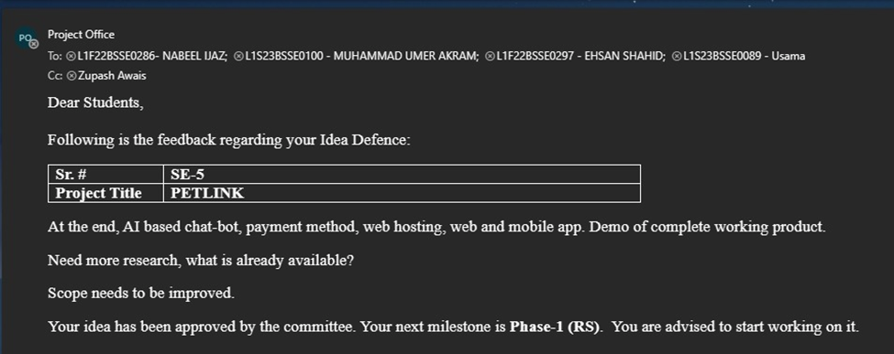
Idea Defence Feedback (Screenshot)

Abstract
PetLink is a cross-platform web and mobile application developed to serve as a comprehensive pet management platform. It provides a centralized digital solution for pet owners, adopters, buyers, and small service providers in Pakistan, enabling them to manage all pet-related activities through a single, user-friendly system.

In today’s fragmented environment, pet owners face significant challenges when they want to sell or adopt a pet, arrange temporary shelter during travel, purchase pet products, or maintain accurate health records. Most activities are currently handled through scattered social media groups, informal WhatsApp listings, or separate unconnected websites. This leads to incomplete information, lack of trust, difficulty in tracking vaccination schedules, unreliable service coordination, and increased risk of missing important pet care deadlines.

The proposed system offers a complete set of functionalities including user and pet profile management, pet adoption and sale listings with proper validation, temporary shelter service requests, an integrated pet product store with secure payment gateway, digital pet health and vaccination record management with automated reminders, Google Maps-based nearby veterinary clinic locator, and a custom AI-driven chatbot for instant user assistance and guidance.

By addressing these issues, PetLink fulfills a vital public need in the growing pet ownership community of Pakistan. It improves pet welfare through better record-keeping and timely care, enhances trust and transparency in pet trading and services, reduces fragmentation in the market, and provides a reliable, accessible platform that brings convenience and organization to thousands of pet lovers and service providers.

System Architecture

High-Level Architecture
PetLink follows a Layered Client-Server Architecture enhanced with scalable cloud components. The system separates presentation, business logic, data management, and external integrations into distinct layers to improve maintainability, scalability, and security.
The architecture consists of:
- Presentation Layer
  - React.js Web Application
  - React Native Mobile Application
- Application Layer
  - API Gateway
  - Authentication Services
  - Business Logic Services
  - Notification Services
- Data Layer
  - MongoDB Atlas Database
  - Redis Cache
- External Service Layer
  - Stripe Payment Gateway
  - Google Maps API
  - AI Chatbot Service
  - Firebase Cloud Messaging (FCM)
To support future growth and increased user traffic, a Load Balancer distributes incoming requests across backend instances while Redis caching reduces database load and improves response time. This architecture provides high availability, better performance, easier maintenance, and support for thousands of concurrent users.

Architecture Diagram
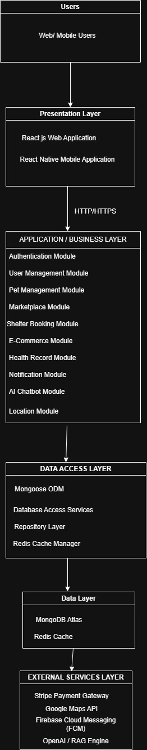

Component Overview
Component | Description
React Web Application | Provides browser-based access to PetLink functionalities.
React Native Mobile Application | Provides mobile access for Android and iOS users.
Load Balancer | Distributes incoming requests among backend services to improve performance and availability.
API Gateway | Central entry point that routes requests to appropriate backend services.
Authentication Service | Handles registration, login, JWT generation, and access control.
Pet Management Service | Manages pet profiles and ownership records.
Marketplace Service | Handles pet adoption and sale listings.
Shelter Booking Service | Processes temporary shelter requests and provider responses.
E-Commerce Service | Manages products, carts, orders, and inventory.
Payment Service | Integrates with Stripe to process secure online payments.
Health Record Service | Stores vaccination records and manages reminder schedules.
Notification Service | Sends push notifications, emails, and real-time alerts.
AI Chatbot Service | Provides automated assistance and pet-related guidance.
Location Service | Retrieves nearby veterinary clinics using Google Maps APIs.
MongoDB Atlas | Stores user, pet, order, listing, and health record data.
Redis Cache | Improves performance by caching frequently accessed data.
Stripe API | Processes online payment transactions securely.
Google Maps API | Provides location and mapping services.
Firebase Cloud Messaging | Delivers push notifications to mobile devices.
OpenAI / RAG Engine | Generates intelligent chatbot responses.

Mapping Design to User Stories

Story ID | Component | Description
US-01 / US-02 | Authentication Module | Verifies inputs, salts and hashes user passwords via bcrypt, and generates stateless JWT tokens for future requests.
US-05 | Pet Profile Module | Creates relational mappings inside the MongoDB document cluster tying unique Pet entries to their respective Owner's User ID.
US-06 / US-07 | Marketplace Module | Registers public data documents within the marketplace data collection with structural attributes indicating adoption or sales pricing.
US-08 | Marketplace Search | Compiles runtime search strings into active multi-field mongo search queries, filtering parameters like species, age, and breed without structural lag.
US-09 | Shelter Request Module | Logs specific time intervals and notes between a pet owner and an available shelter provider entry.
US-10 / US-32 | Payment & Order Engine | Interfaces with Stripe sandbox endpoints to execute electronic transactions, outputting immutable order records on success.
US-11 / US-12 | Digital Health Vault | Adds sub-document medical logs to specific pet profiles and flags upcoming chronological tasks for automated system reminders.
US-13 | AI Chatbot Adapter | Accepts query strings from the client app, forwards them to the AI engine with a structured prompt, and renders the reply
US-14 | Location Engine | Pulls latitude/longitude from client device sensors and maps surrounding veterinary clinic landmarks via Google Maps
US-15 | Notification Module | Distributes alerts (e.g., booking status updates, checkout success) in real time.
US-17 to US-26 | Admin Management UI | Locks product ingestion forms behind explicit admin security routes, managing live store inventories and sales logs.

Detailed System Design

Module Decomposition

Authentication & User Management Module
Purpose:

Enforces platform onboarding rules, evaluates credentials, secures user passwords, and handles session validation using stateless headers across both web and mobile client applications.

Sub-Modules & Descriptions

Sub-Module | Functional Description
RegistrationManager | Validates incoming registration fields (e.g., name, email, password, role) and creates a new user document collection entry.
LoginGatekeeper | Handles secure user and administrator authentication requests, issuing a stateless payload on verified credentials
BCryptHasher | Provides secure cryptographic operations, salting and hashing plaintext passwords before database storage to prevent reverse-engineering.
JWTTokenSigner | Generates and cryptographically signs stateless JSON Web Tokens with a dedicated expiration window to authorize future API requests.

Pet Profile Module
Purpose:

Handles CRUD operations for pet statistics and health profiles.

Sub-Modules & Descriptions

Sub-Module | Functional Description
Profile Creator | Saves new pet records including name, species, breed, age, weight, and image links.
Profile Editor | Updates profile values when weight, age, or medical details change.
Profile Remover | Removes pet profiles from the active view.

Marketplace Module
Purpose:

Coordinates pet adoption and sale listings

Sub-Modules & Descriptions

Sub-Module | Functional Description
Listing Creator | Validates prices, matches listings to pet profiles, and creates marketplace records.
Feed Viewer | Fetches listings and sorts them by date and type.
Search Filter | Performs query operations based on breed, species, location, and price.
Listing Status Manager | Marks listings as sold, adopted, or inactive.

Shelter Booking Modules
Purpose:

Coordinates boarding bookings between owners and providers

Sub-Modules & Descriptions

Sub-Module | Functional Description
Booking Creator | Creates booking requests with start/end dates, pet profiles, and notes.
Provider Panel | Shows pending, active, and completed booking requests to providers
Status Manager | Lets providers accept or reject bookings, which updates database state.

E-Commerce Modules
Purpose:

Handles Store Operations, Cart Updates and Inventory tracking

Sub-Modules & Descriptions

Sub-Module | Functional Description
Storefront Catalog | Shows product categories, names, prices, and images.
Cart Manager | Handles additions, removals, and quantity changes in the cart.
Inventory Manager | Tracks product stock levels and updates availability flags.

Payment Processing Module
Purpose:

Manages checkout transactions and stripe integrations

Sub-Modules & Descriptions

Sub-Module | Functional Description
Price Calculator | Computes the total cost (items + delivery) server-side.
Stripe Intent Handler | Requests payment intents from Stripe and returns client secrets to the client.
Webhook Monitor | Listens for Stripe payment success notifications to update order records.

Health Vault and Scheduler
Purpose:

Manages pet health histories and schedules vaccination reminders.

Sub-Modules & Descriptions

Sub-Module | Functional Description
Record logger | Logs vaccine names, dates, and calculated next due dates.
Daily cron worker | Checks database records daily to find upcoming vaccine due dates
Reminder triggers | Sends push notifications and email alerts when vaccine due dates approach

AI Chatbot Module
Purpose:

Provides natural language response support.

Sub-Modules & Descriptions

Sub-Module | Functional Description
Chat Interface | Renders conversation messages in a chat interface
Session Handler | Restores recent messages to maintain context.

Location Module
Purpose:

Locates nearby veterinary clinics.

Sub-Modules & Descriptions

Sub-Module | Functional Description
GPS Coordinate Tracker | Retrieves current device coordinates
API Proxy | Safe backend proxy that queries Google Places API using secret keys
Map Pin Renderer | Plots nearby veterinary clinics on the map view.

Notification Module
Purpose:

Manages push, web socket, and email alerts.

Sub-Modules & Descriptions

Sub-Module | Functional Description
FCM Integrator | Sends push notifications to mobile devices.
Mail Sender | Sends HTML-formatted emails via SMTP.
Web Socket Service | Sends real-time alerts to active frontend sessions.

Data Processing Modules
Purpose:

Handles database read and write tasks

Sub-Modules & Descriptions

Sub-Module | Functional Description
Schema Validator | Validates model data formats using Mongoose templates
DB Connector | Maintains connection pools to the cloud database

API Layer
Purpose:

Manages integrations with external services.

Sub-Modules & Descriptions

Sub-Module | Functional Description
Third-Party Handshakes | Coordinates API requests to Stripe, Google Maps, and Open LLM for Rag.

Data Flow Description

Data Flow Diagram Level 0

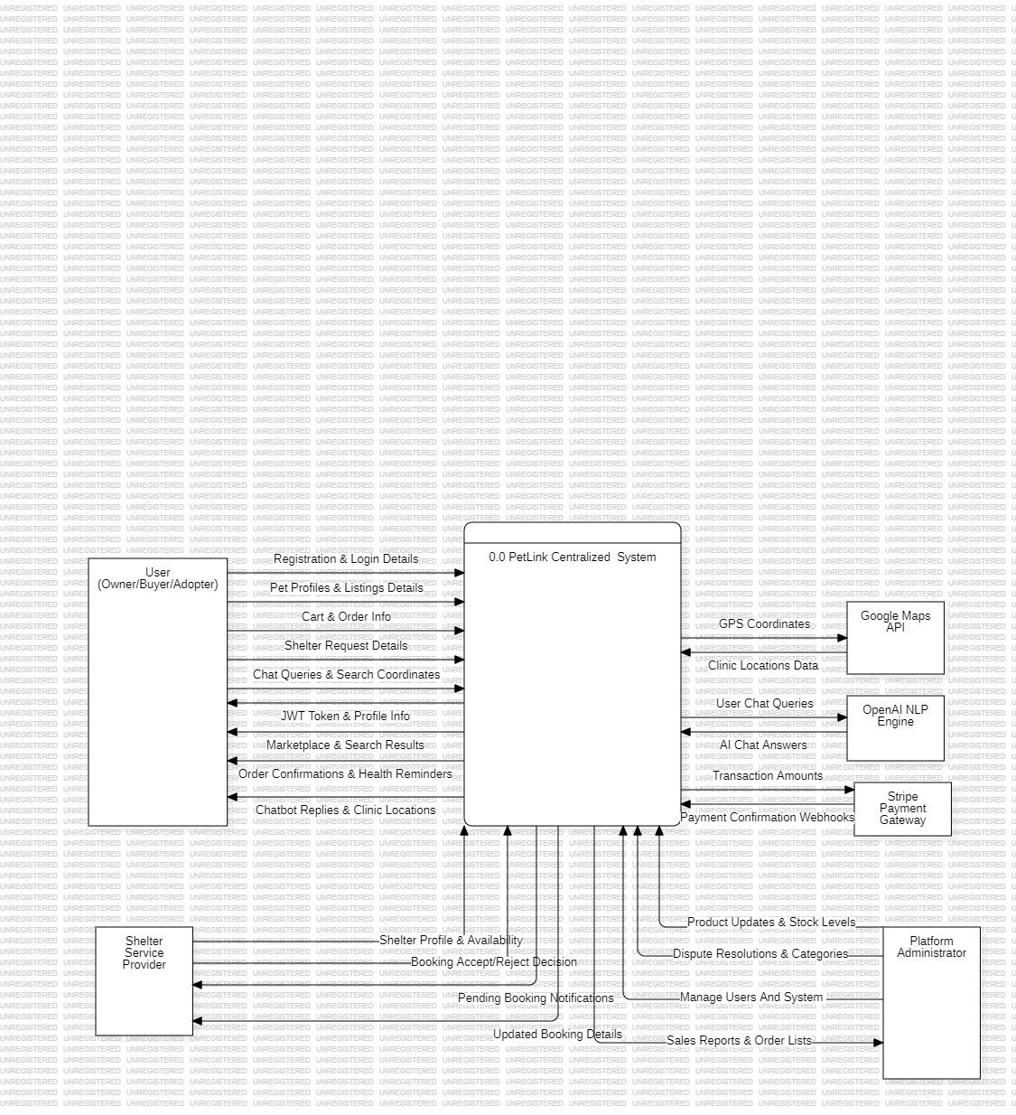

Data Flow Diagram Level 1

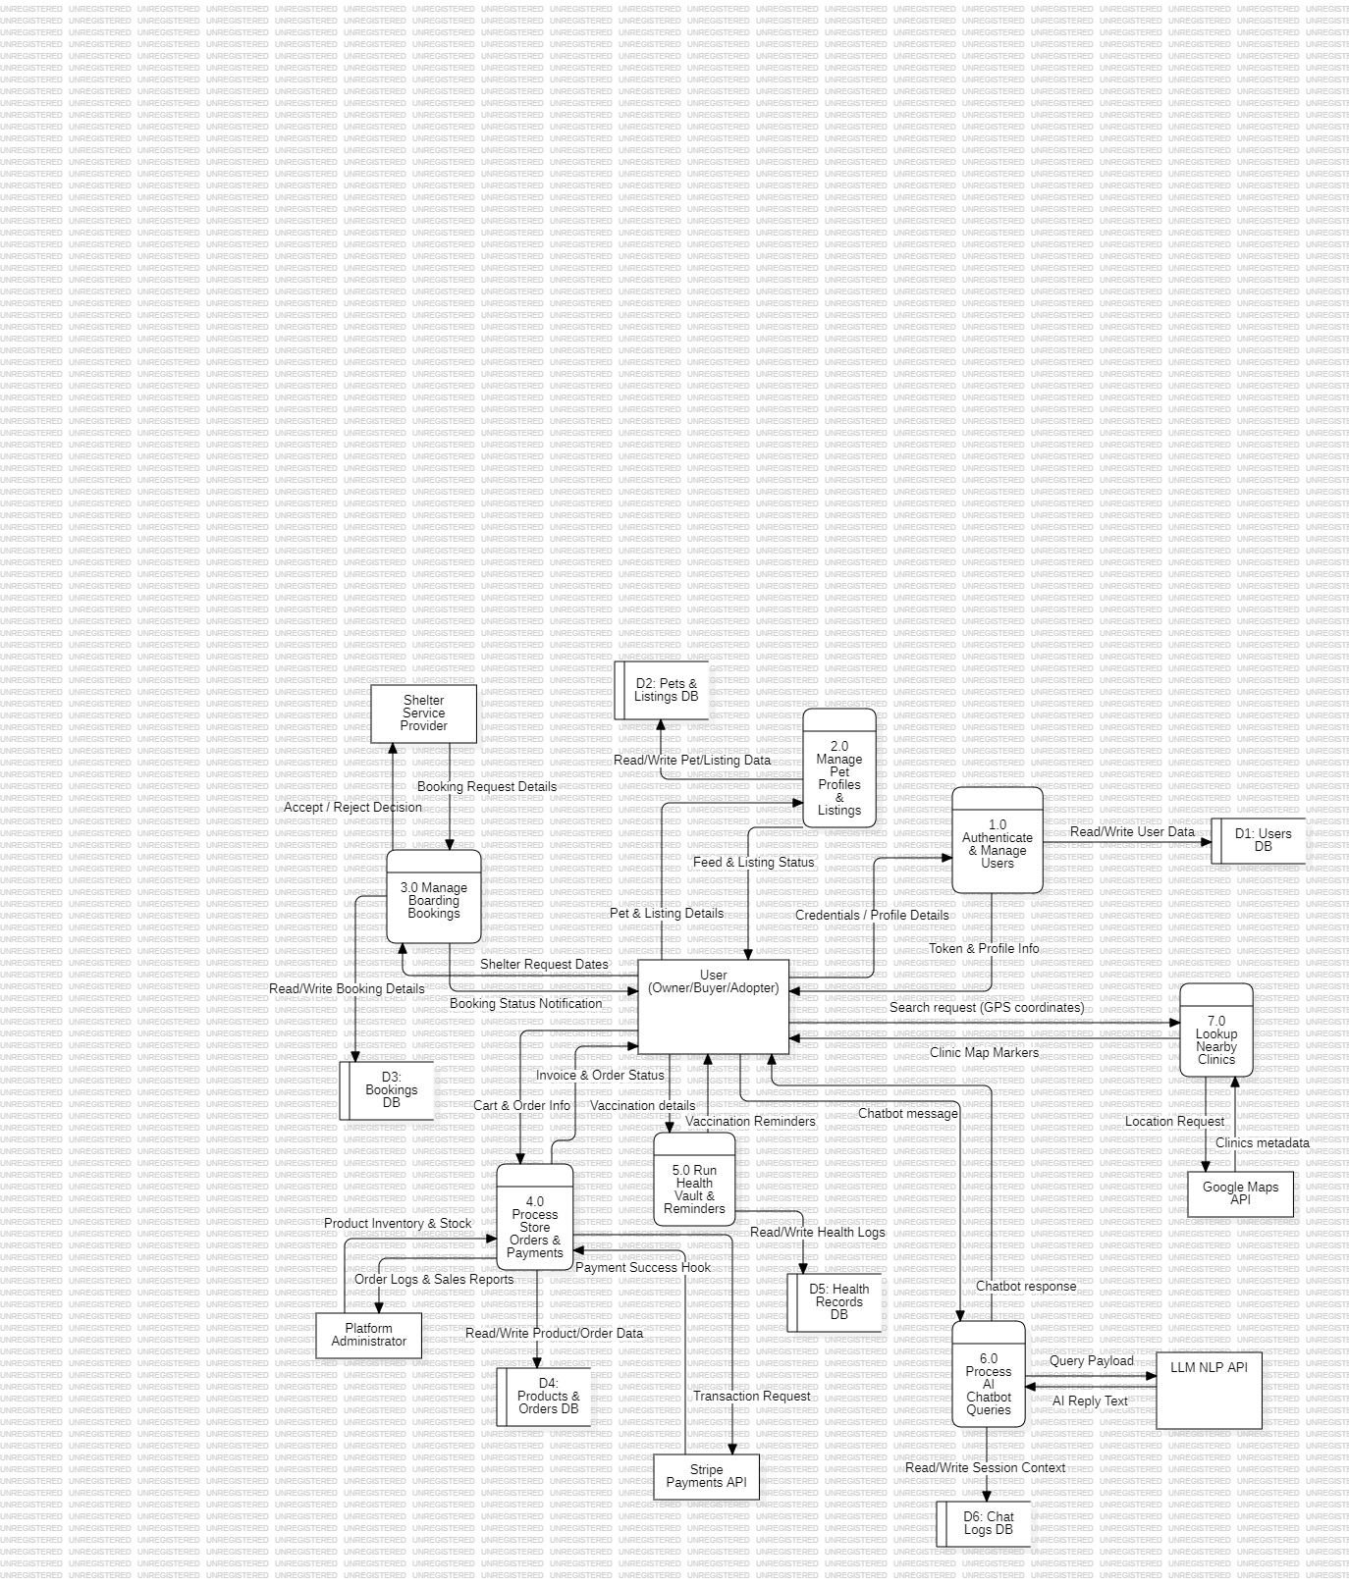

UML Diagrams

Use Case Diagram:

User Registration and Authentication
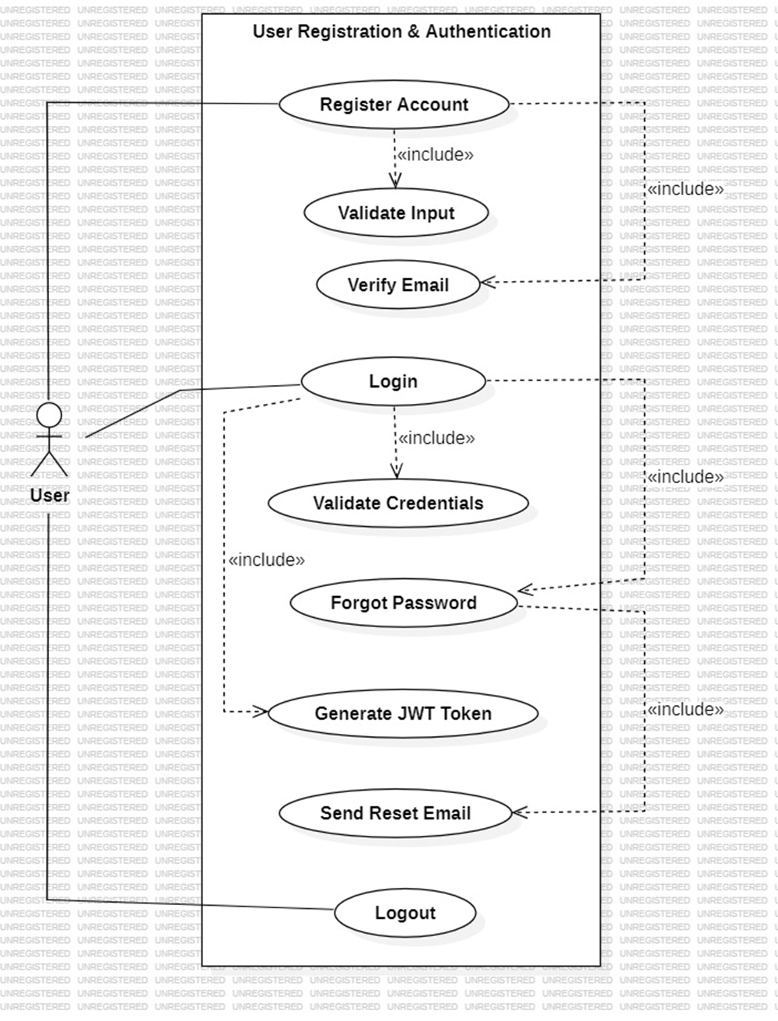
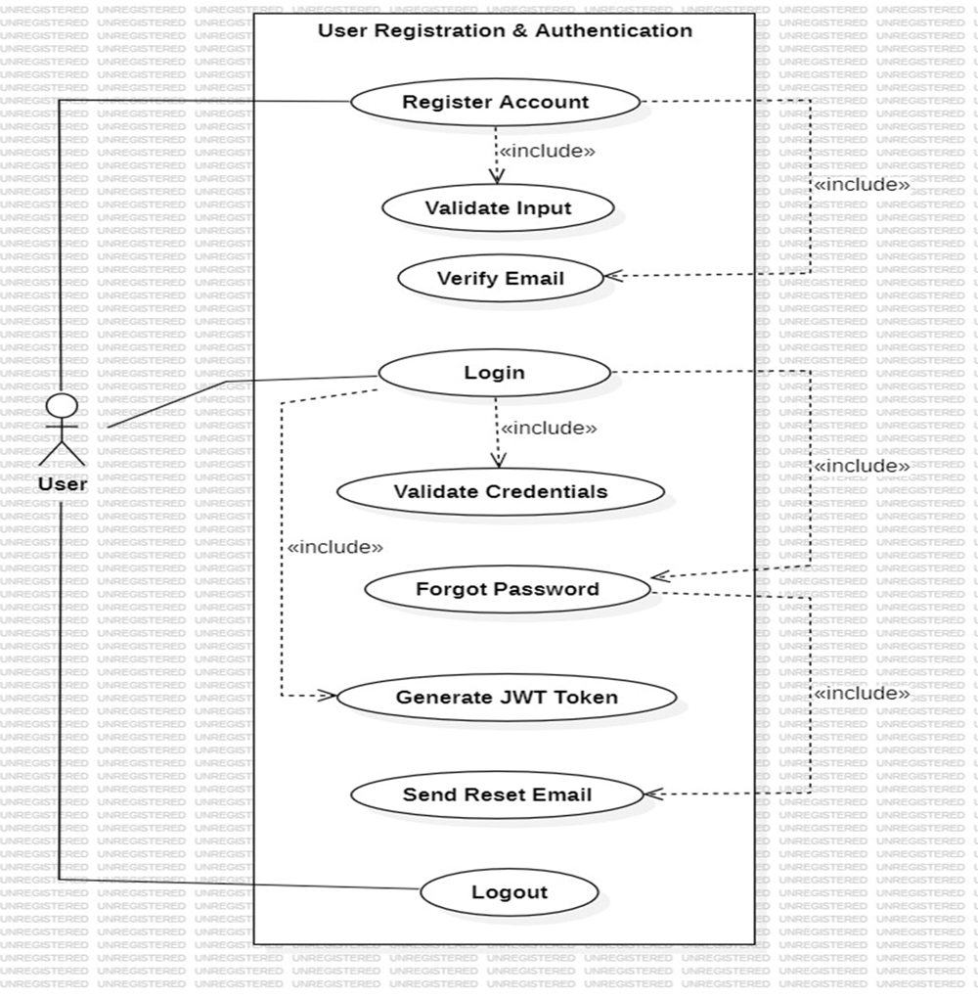

Manage User Profile
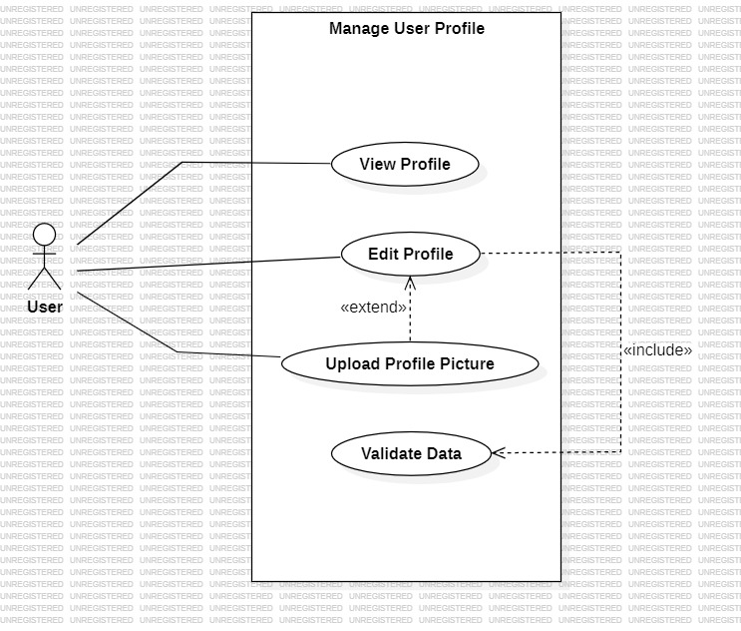

Create and Manage Pet Profile
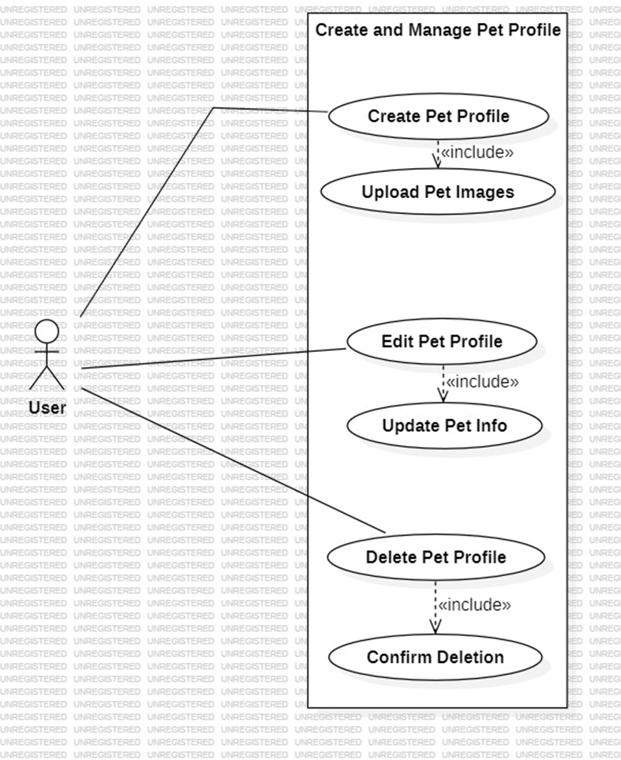

Manage Pet Listing
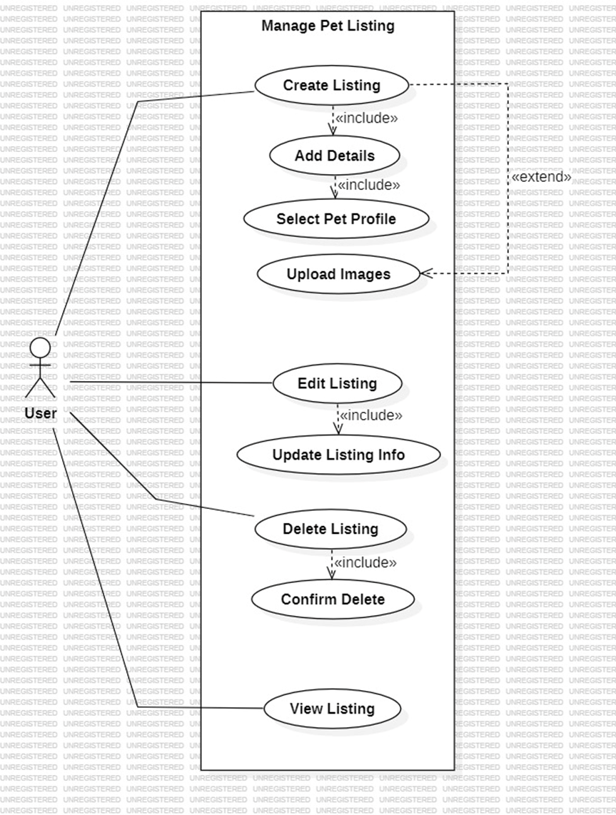

Request Temporary Shelter
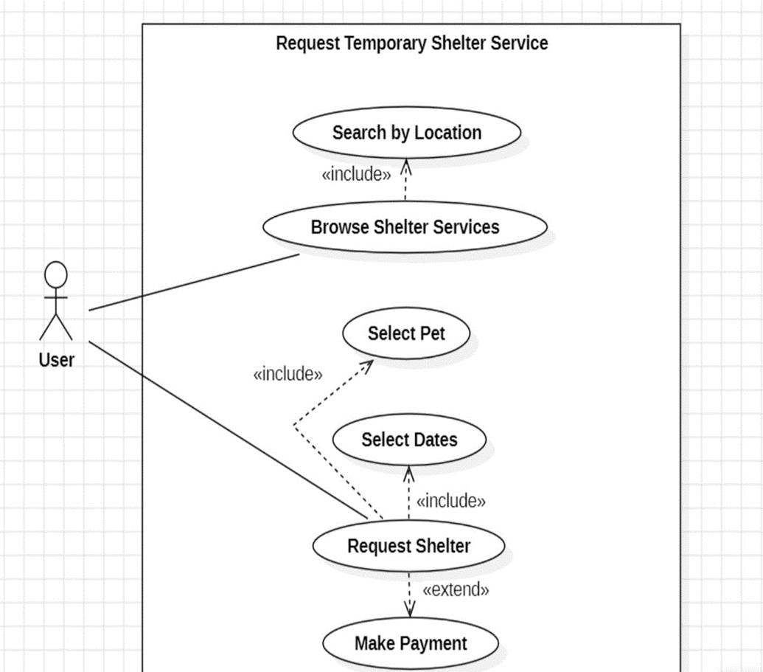

Purchase Pet Product
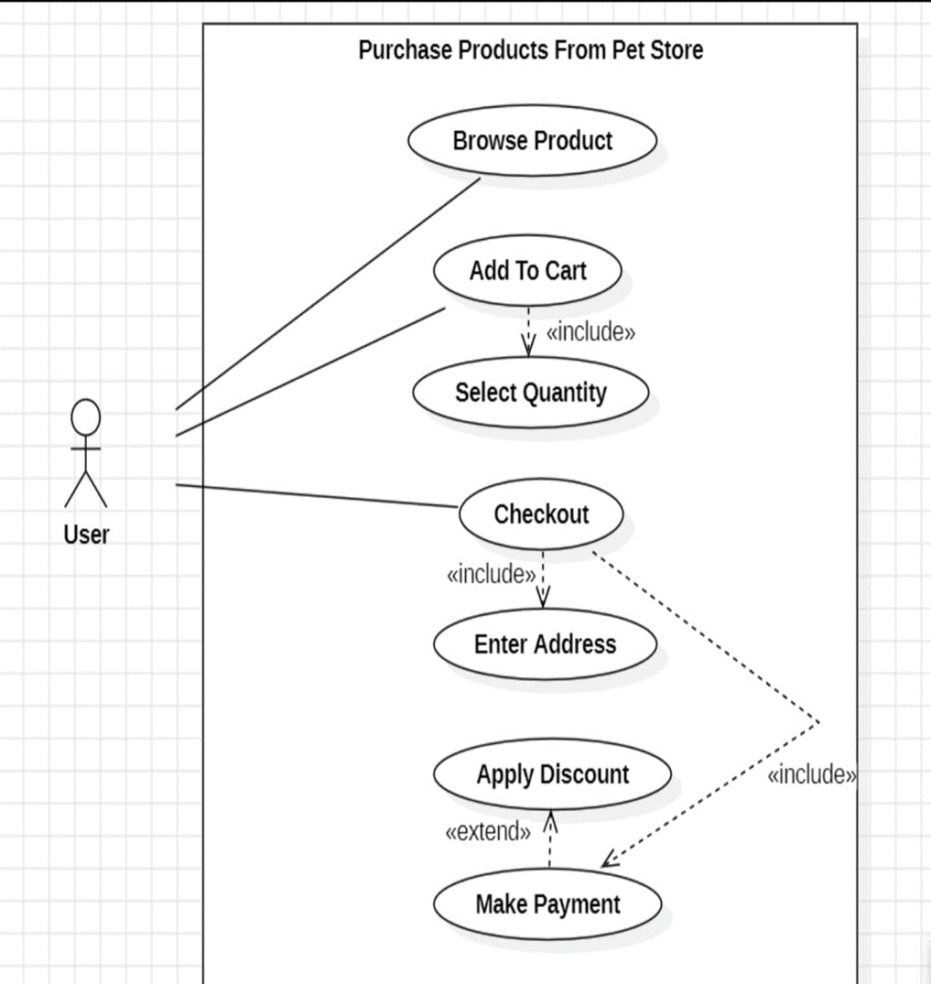

Manage Pet Health Records
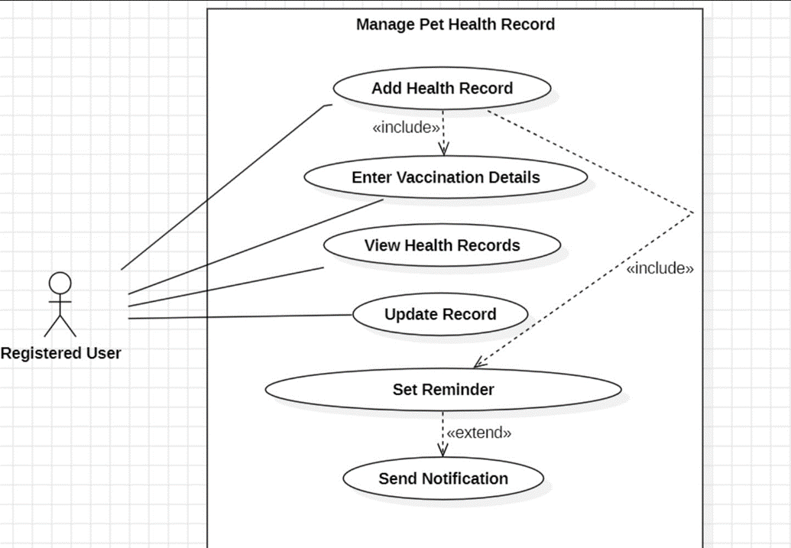

Interact With AI Chatbot
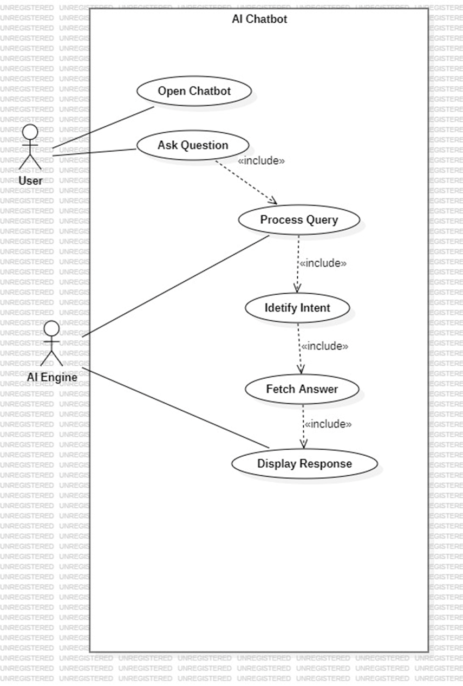

Find Nearby Veterinary Clinics
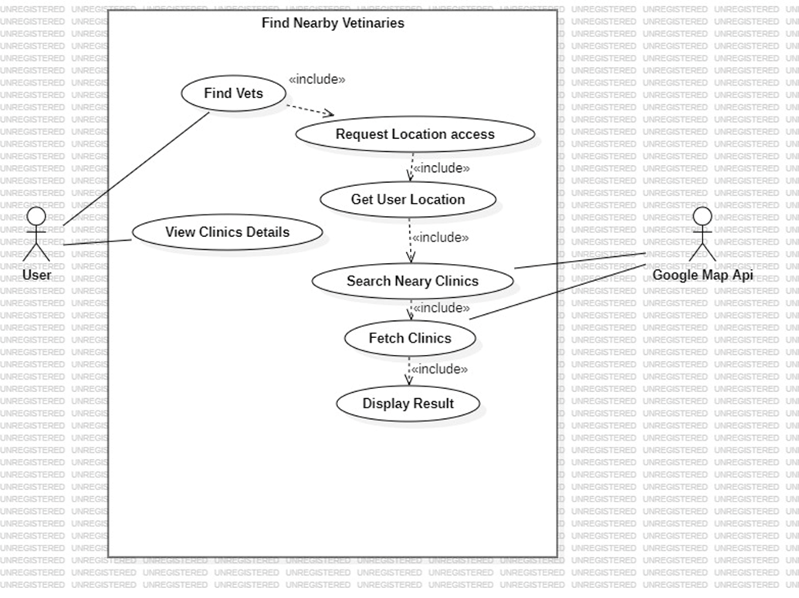

Admin Store Management
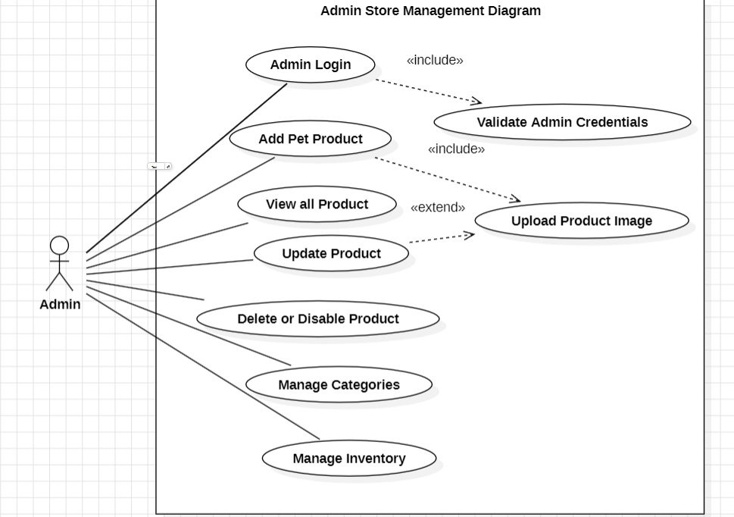

Class Diagram
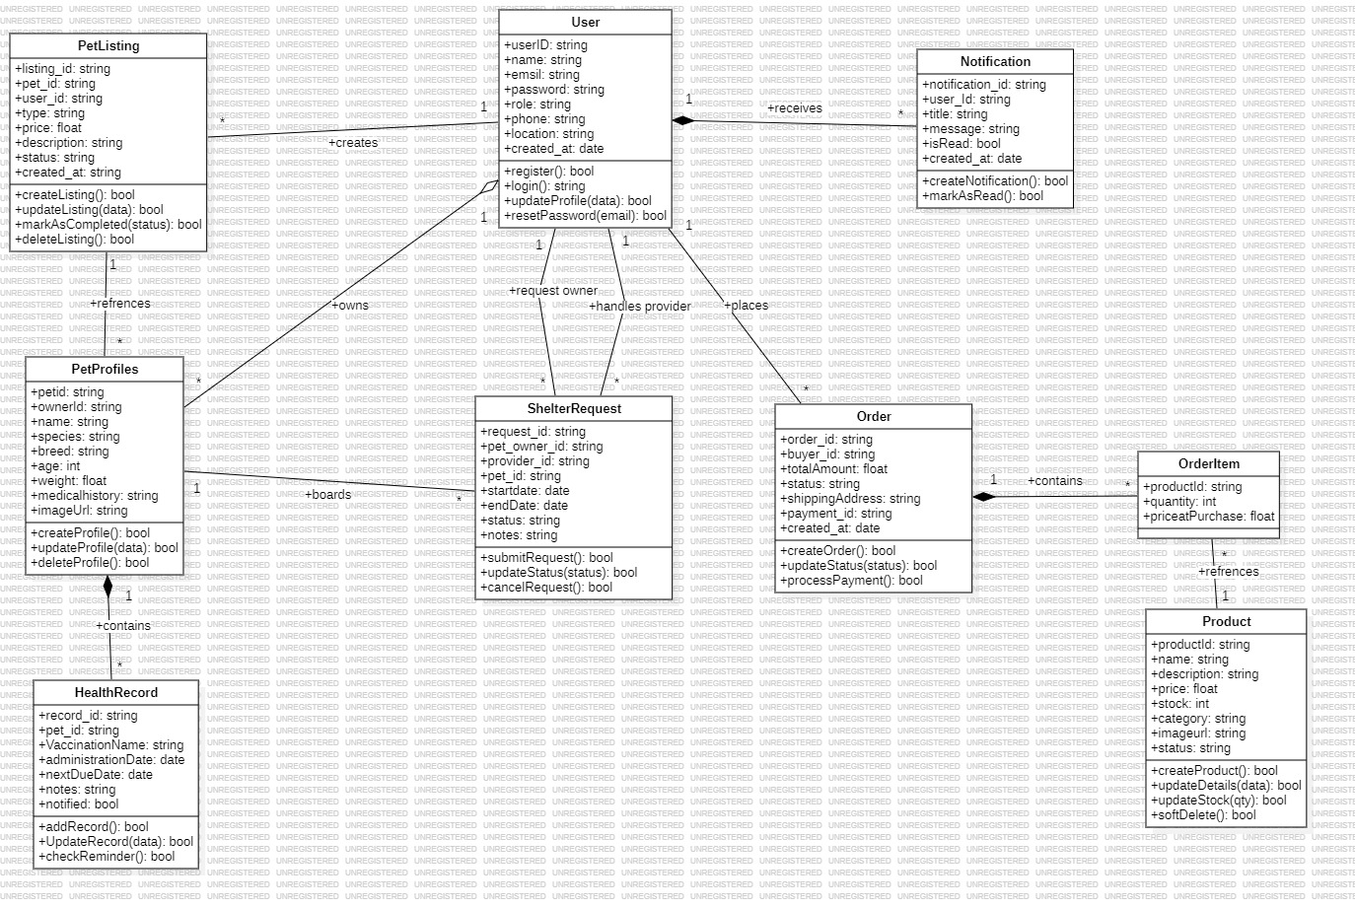

Sequence Diagram

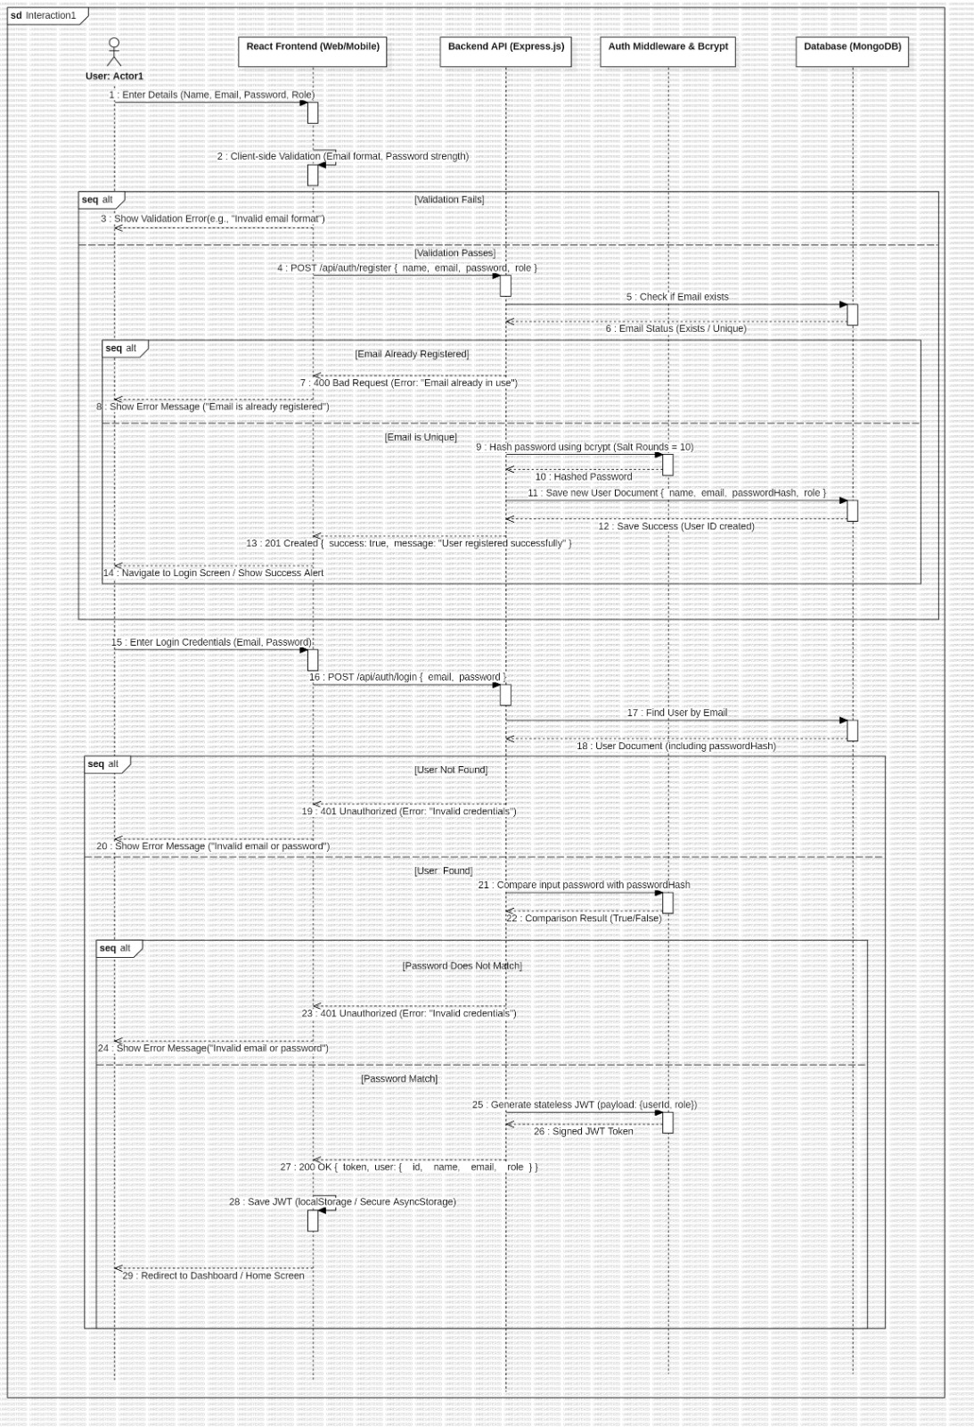
User Authentication

Pet Marketplace Purchase

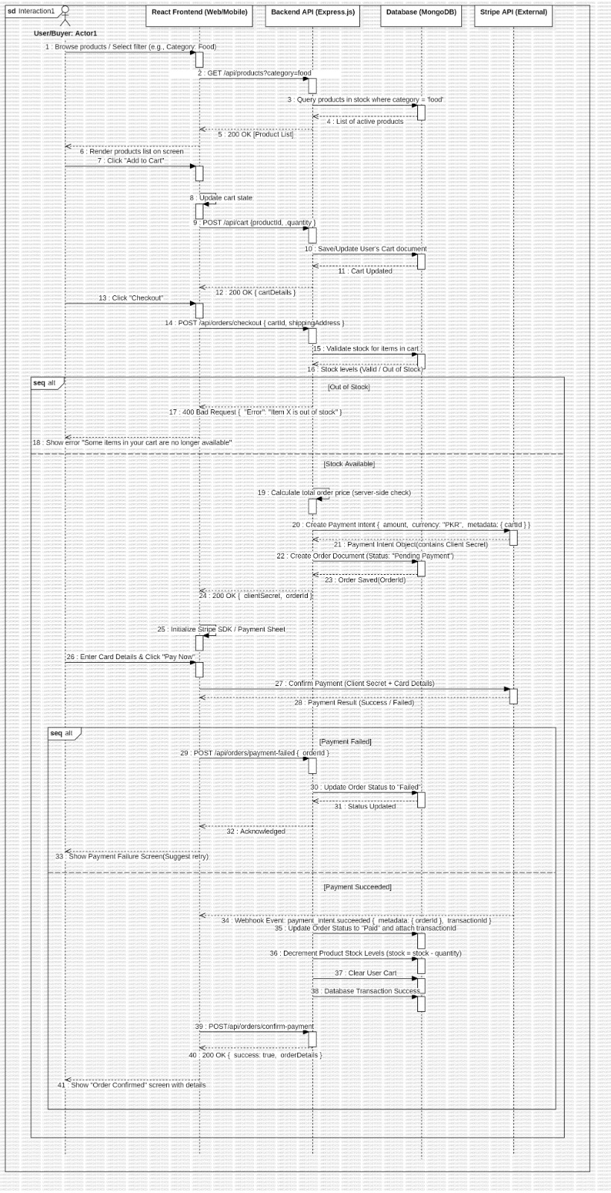

Shelter Service Request
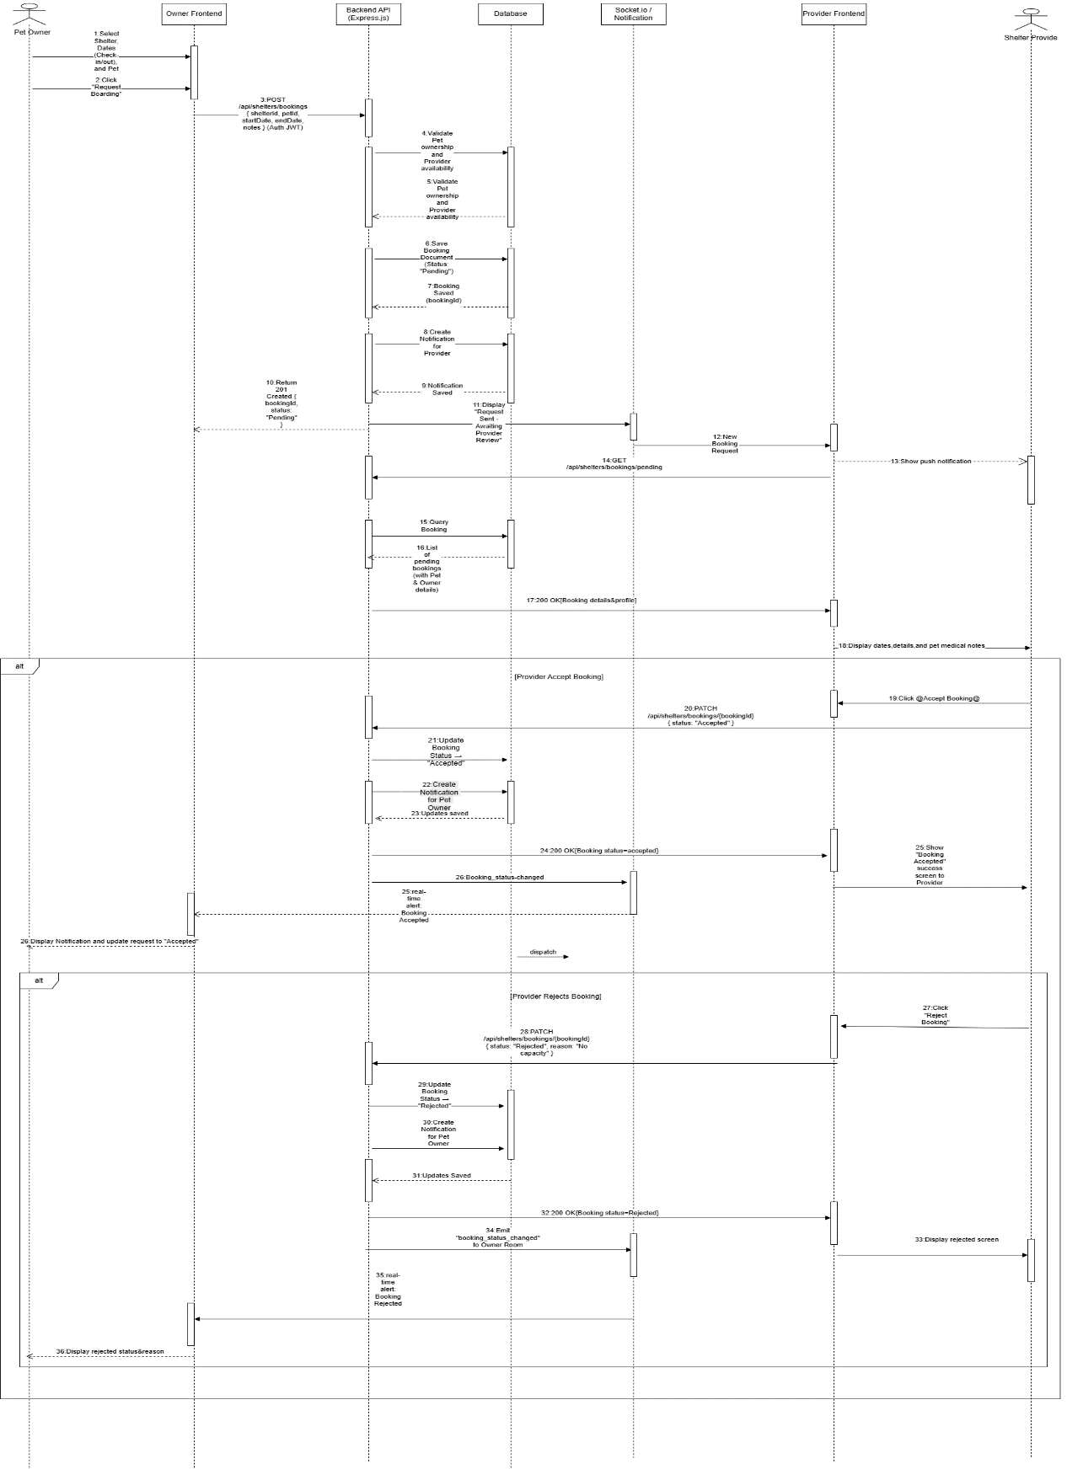

Create Listing
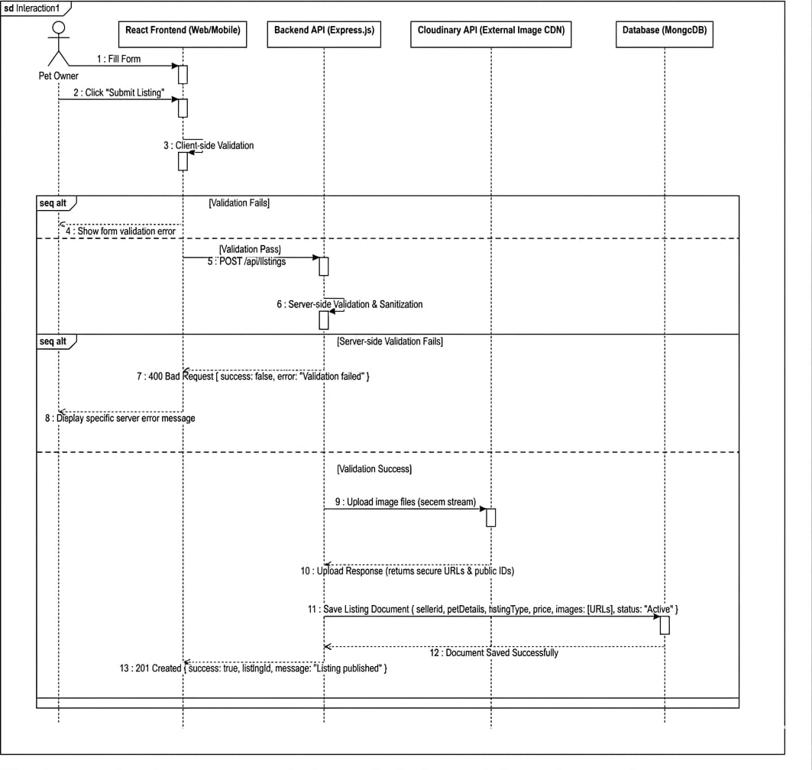

AI Chatbot Interaction

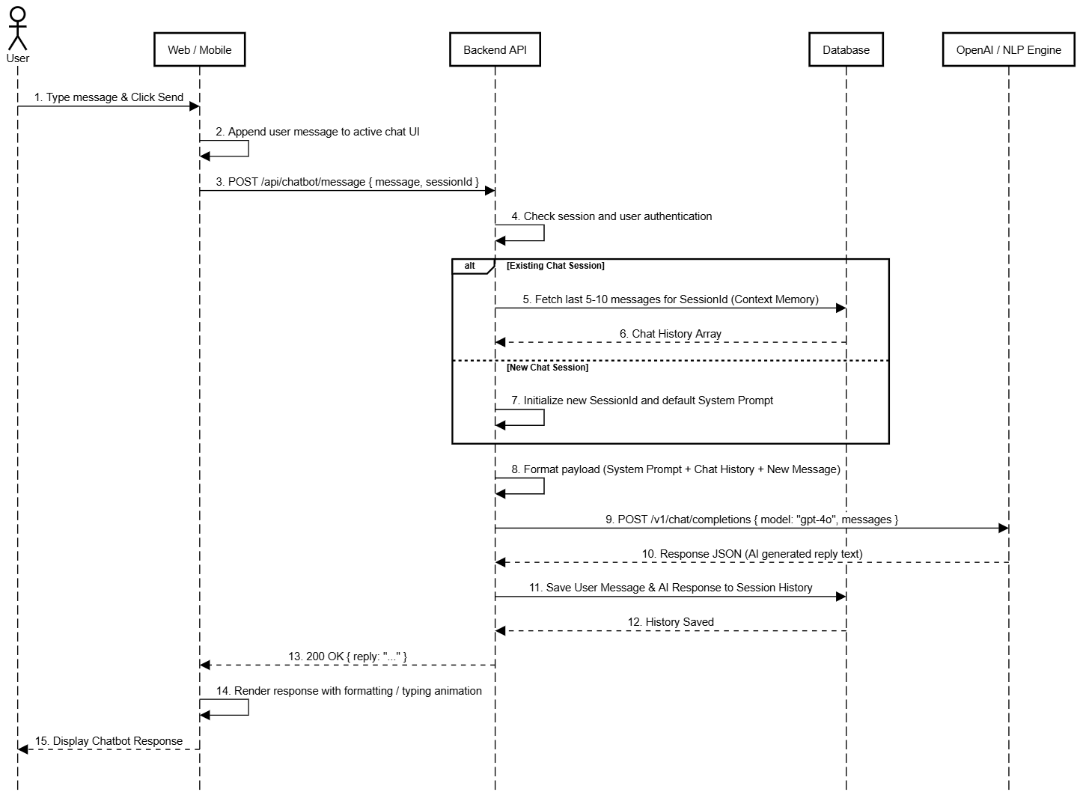

Vaccination Reminder
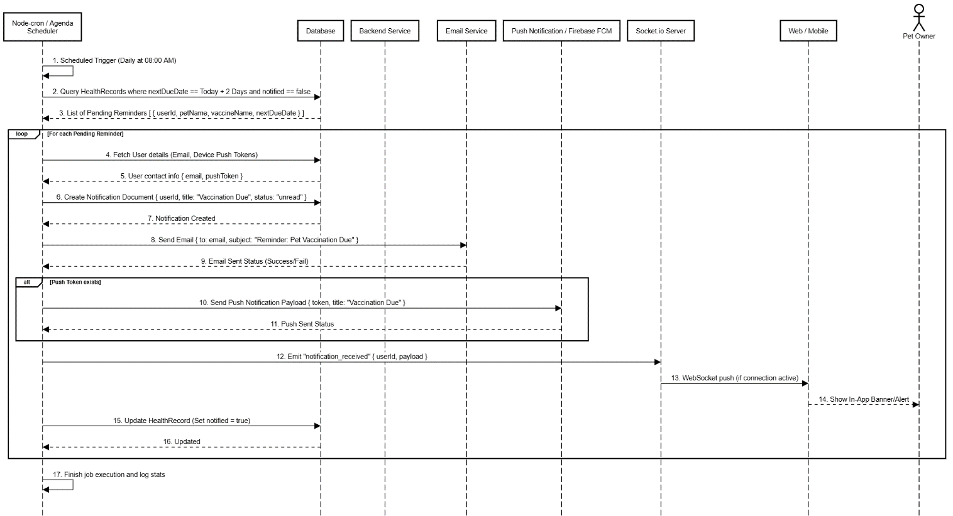

Admin Product Management
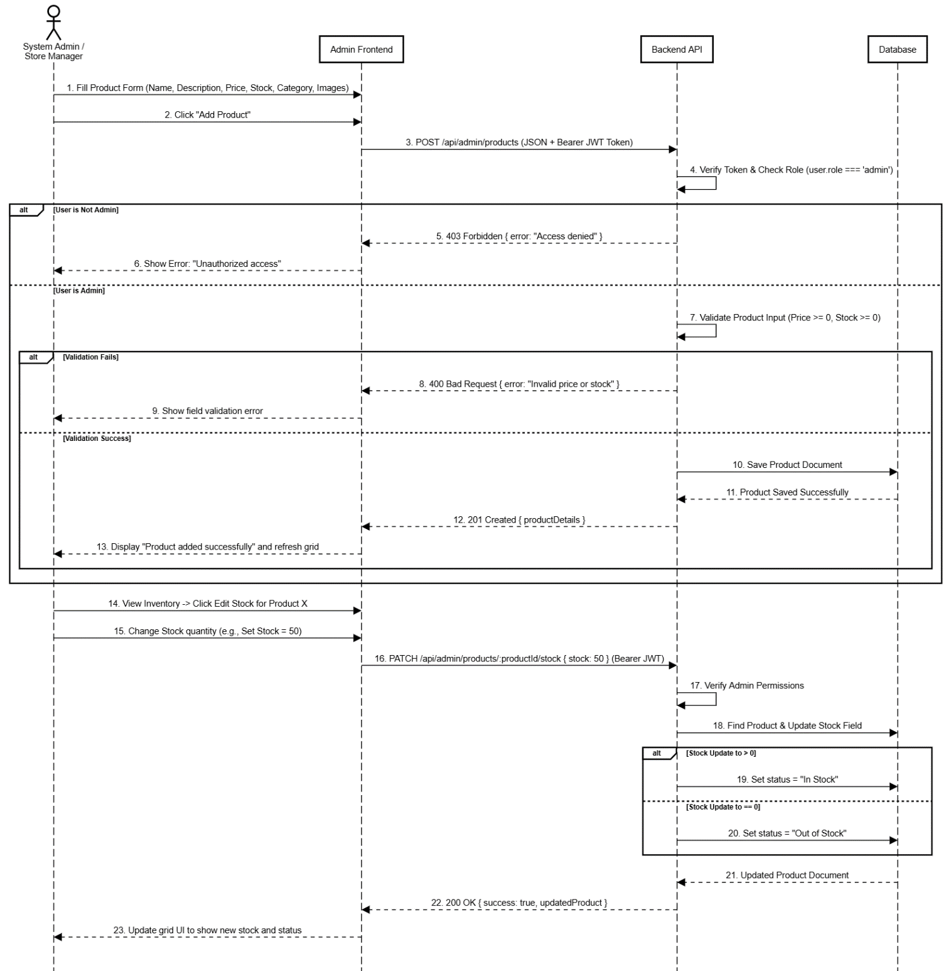

Find Nearby Clinics
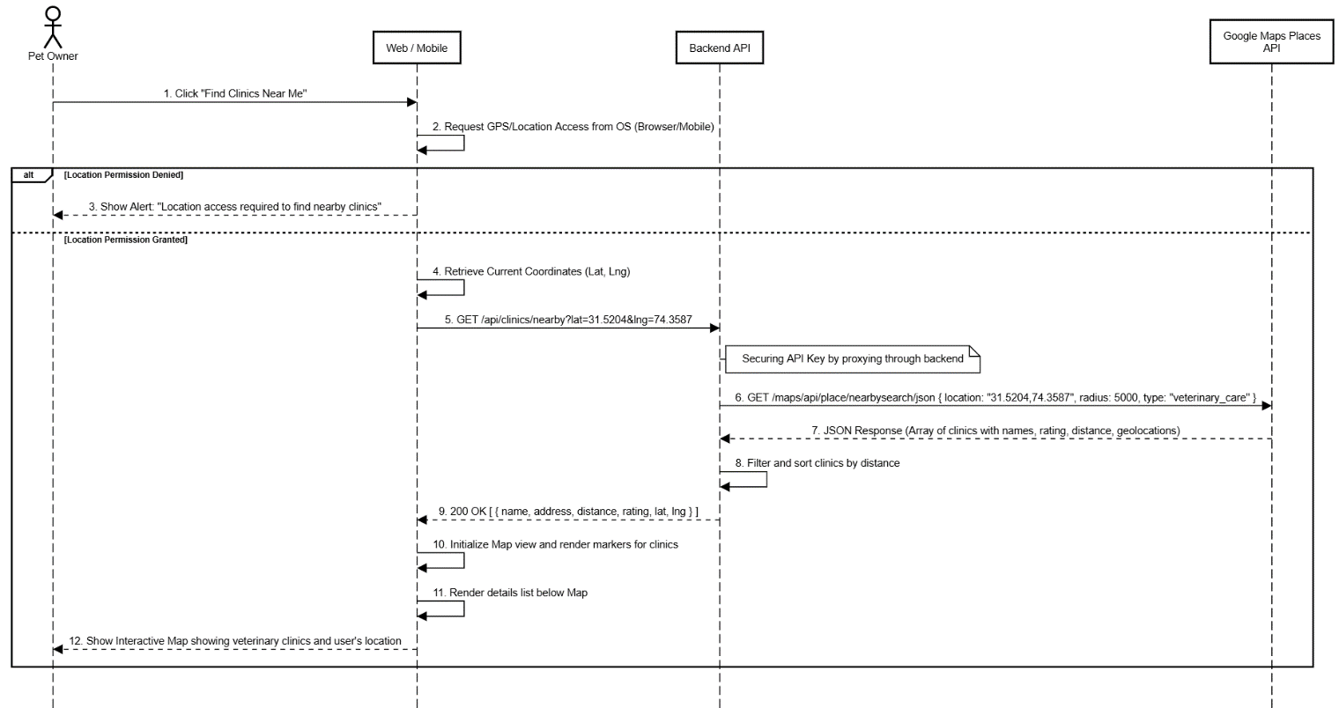

Database Design (ERD)

ER Diagram

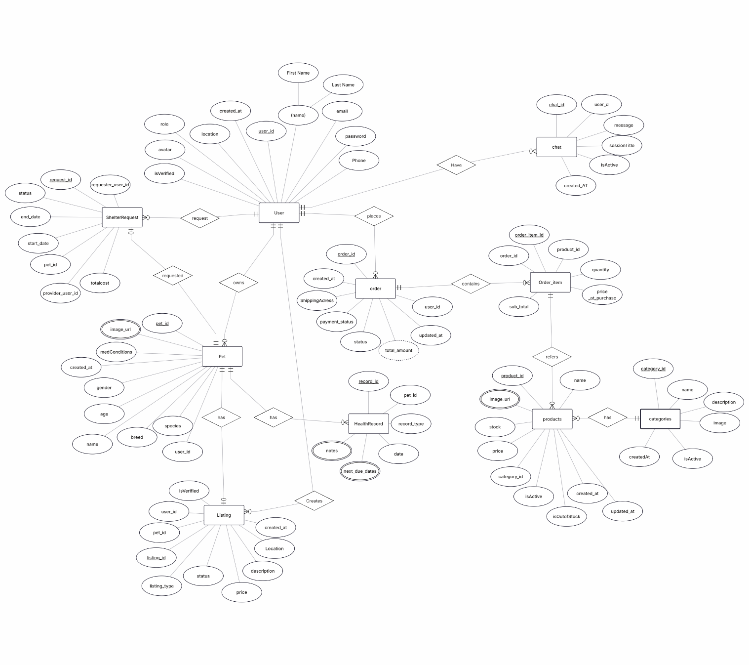

Schema Tables

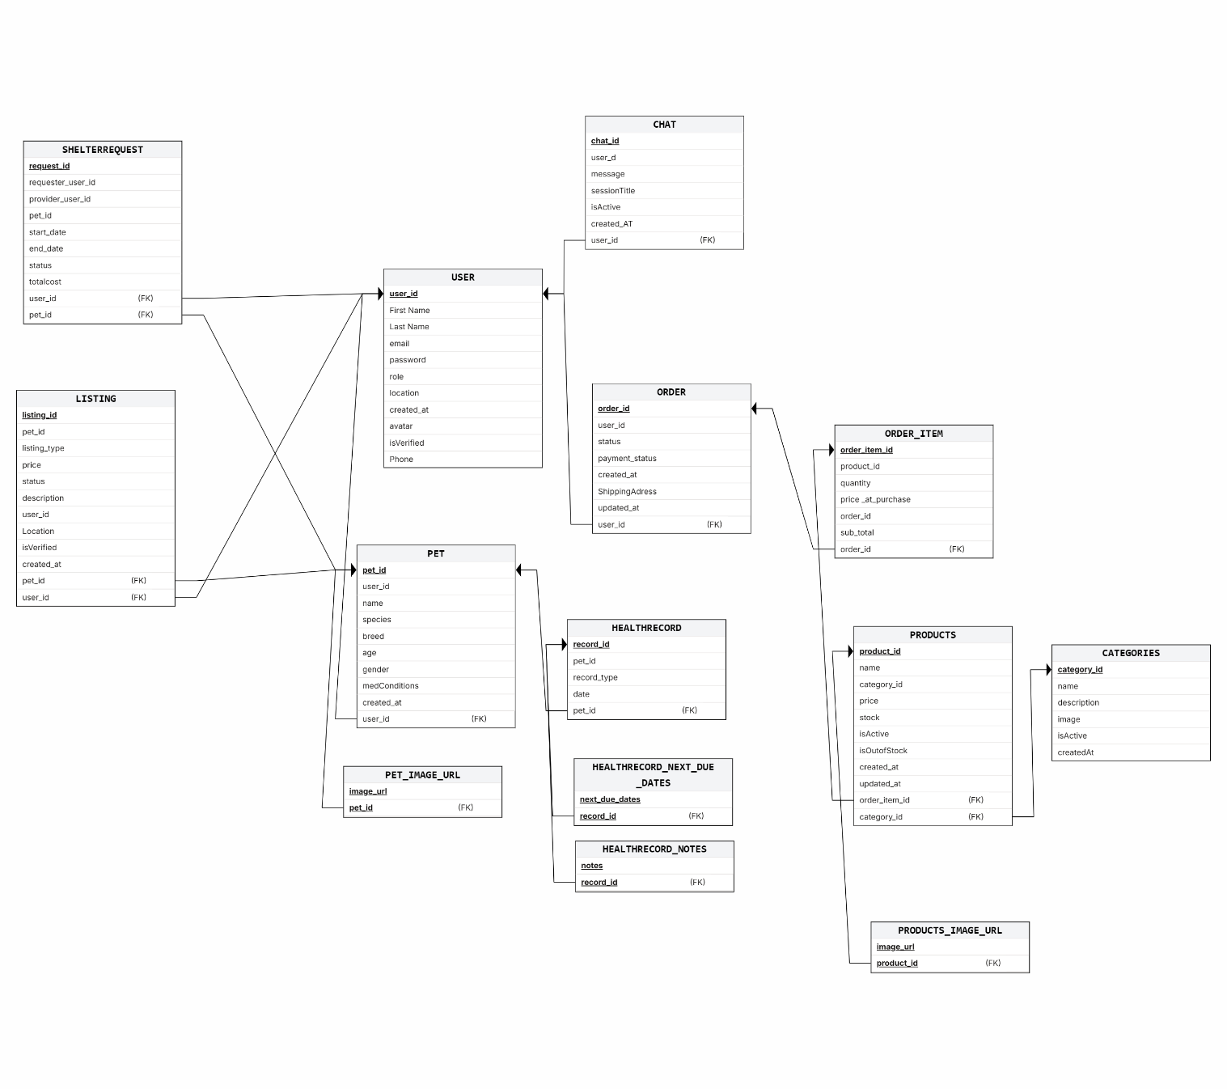

API Design
Endpoint | Method | Input | Output
/api/auth/register | POST | {name, email, password, role} | User registration confirmation
/api/auth/login | POST | {email, password} | Authentication token + user details
/api/auth/profile | PUT | userId, name, phone, address | Updated user profile
/api/pets | POST | ownerId, name, species, breed, ageMonths, weightKg, imageUrl | Pet profile creation confirmation
/api/pets | GET | ownerId | List of owned pet profiles
/api/listings | POST | petId, sellerId, type, price, description | Marketplace listing creation confirmation
/api/listings | GET | type, category, search, location | List of matching active listings
/api/listings/{id}/status | PUT | listingId, status | Updated listing details
/api/shelters/bookings | POST | petOwnerId, providerId, petId, startDate, endDate | Booking request confirmation
/api/shelters/bookings/pending | GET | providerId | Pending boarding requests
/api/shelters/bookings/{id}/status | PATCH | bookingId, status | Updated booking status
/api/products | GET | category, search | List of matching shop products
/api/admin/products | POST | name, description, price, stock, category, imageUrls | Product creation confirmation
/api/admin/products/{id}/stock | PATCH | productId, stock | Updated product inventory
/api/orders/checkout | POST | cartId, shippingAddress | Stripe Payment Intent clientSecret + orderId
/api/orders/confirm-payment | POST | orderId | Payment confirmation status
/api/chatbot/message | POST | message, sessionId | AI reply message
/api/clinics/nearby | GET | latitude, longitude | List of nearby veterinary clinics
/api/notifications | GET | userId | List of active notifications
/api/logout | POST | userId | Logout confirmation

UI/UX Design (Prototypes)

Wireframes:

Navigation Flow:

Generic App Flow

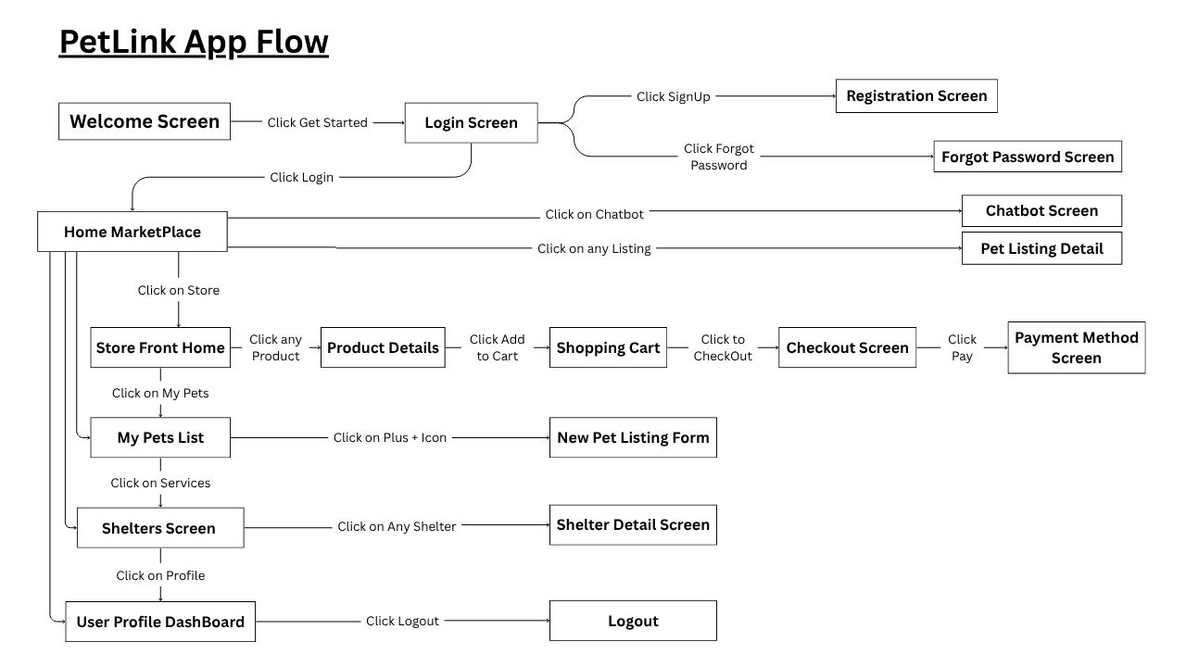
Flow as admin

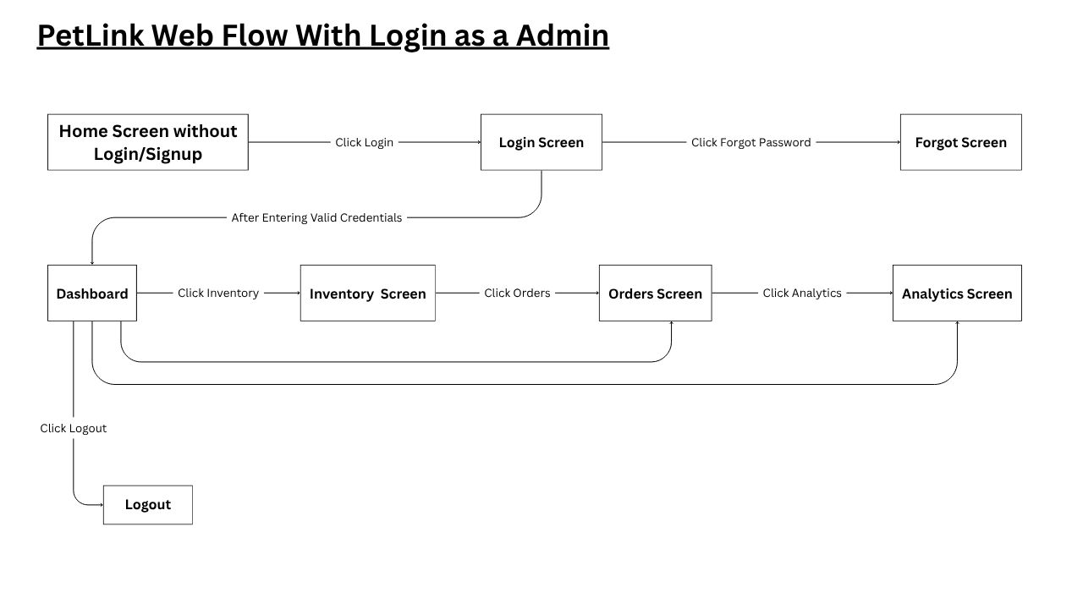
Flow as a user

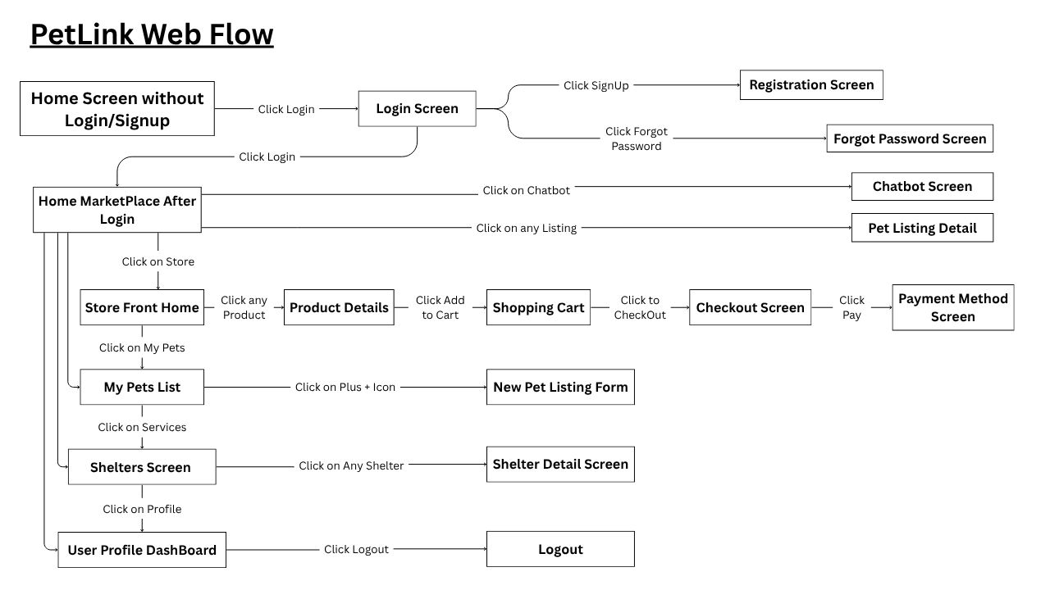

Screens
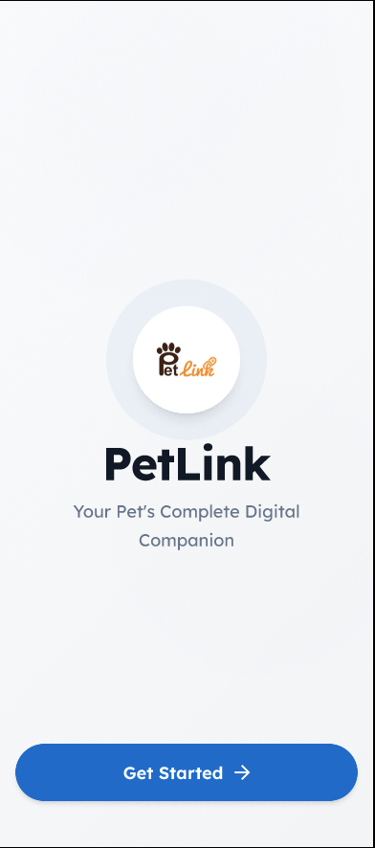

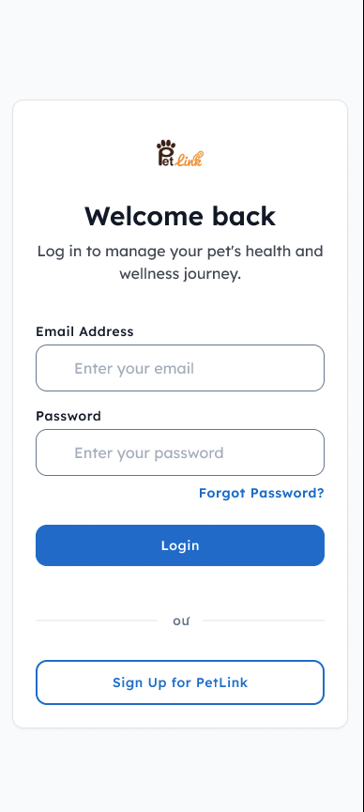

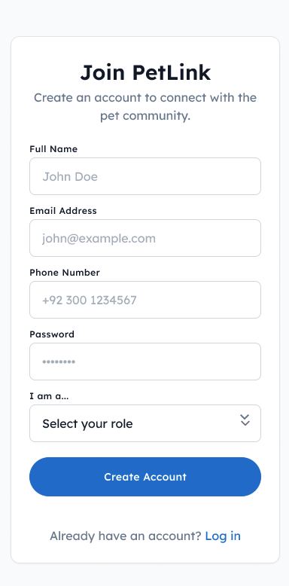

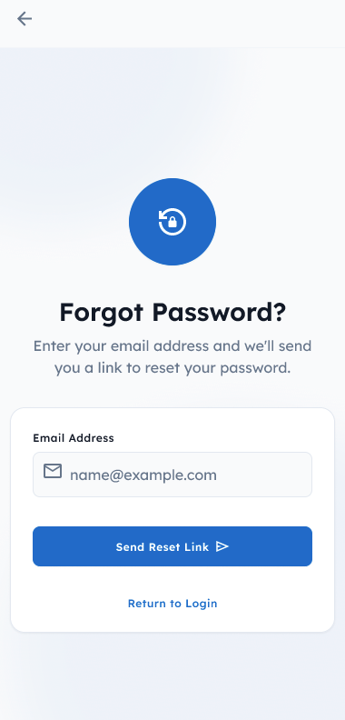

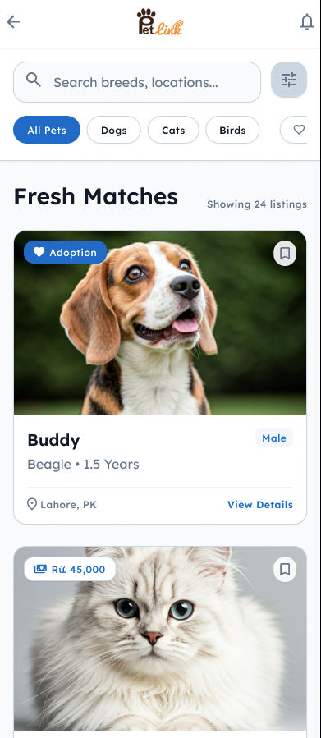
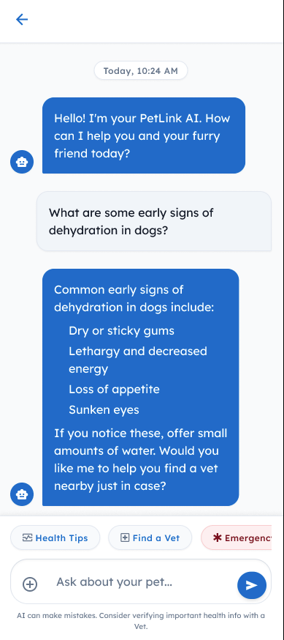

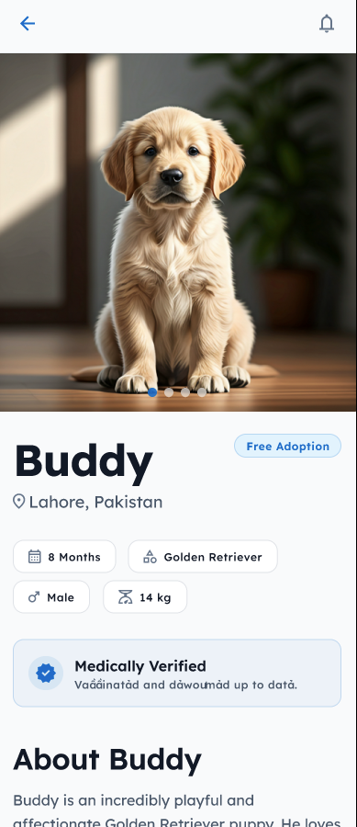
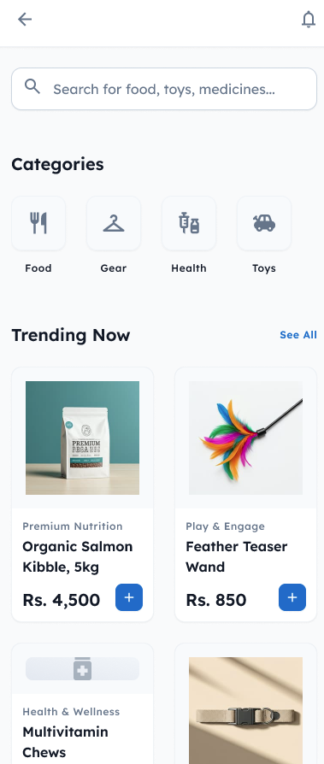

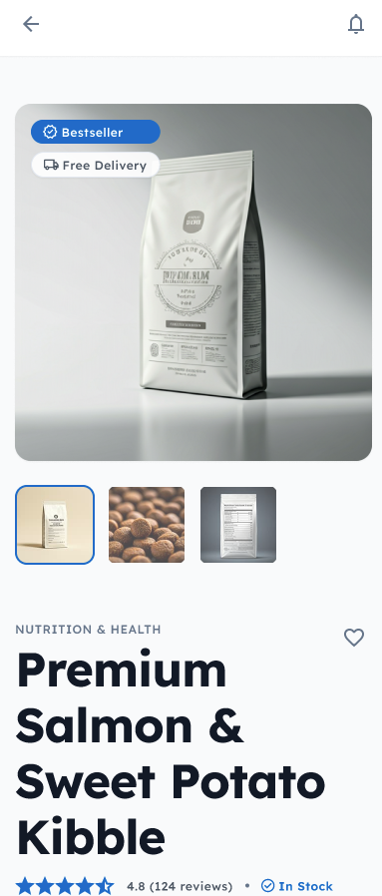

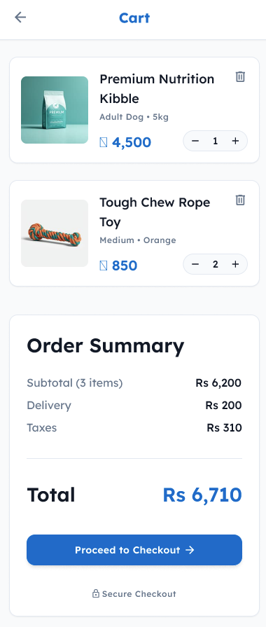

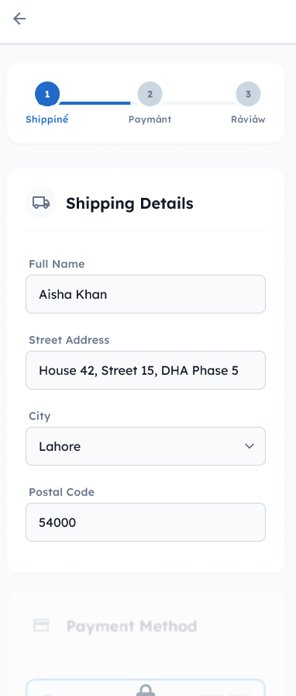
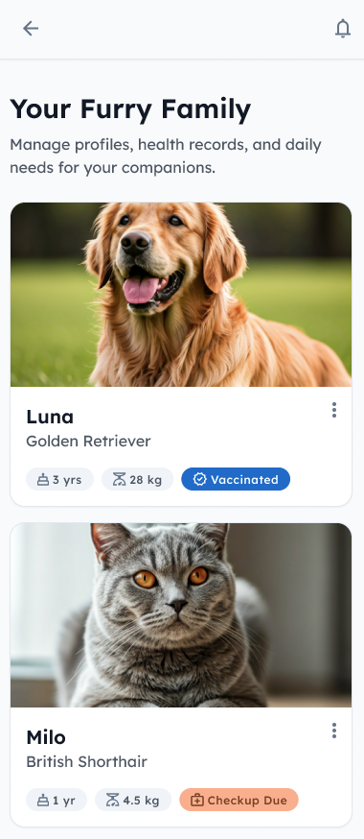

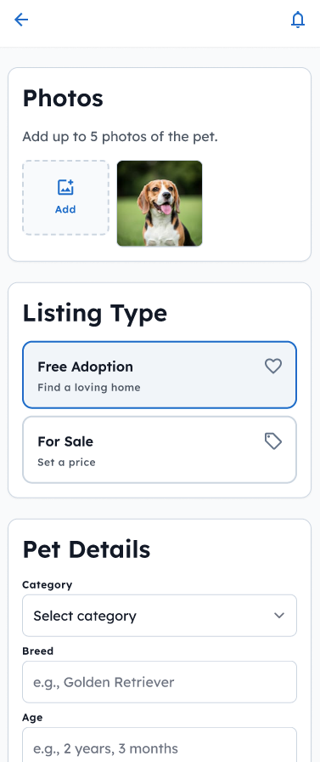

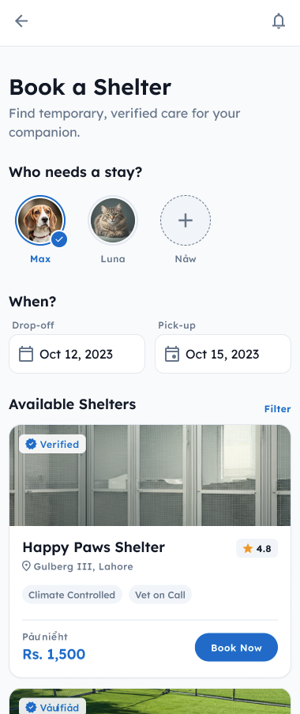
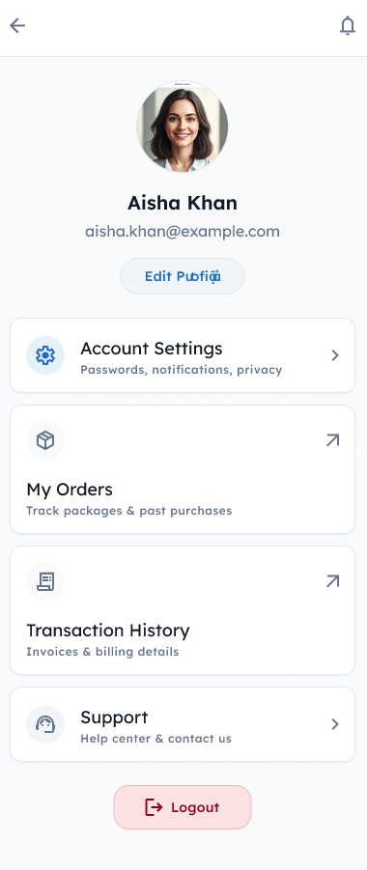

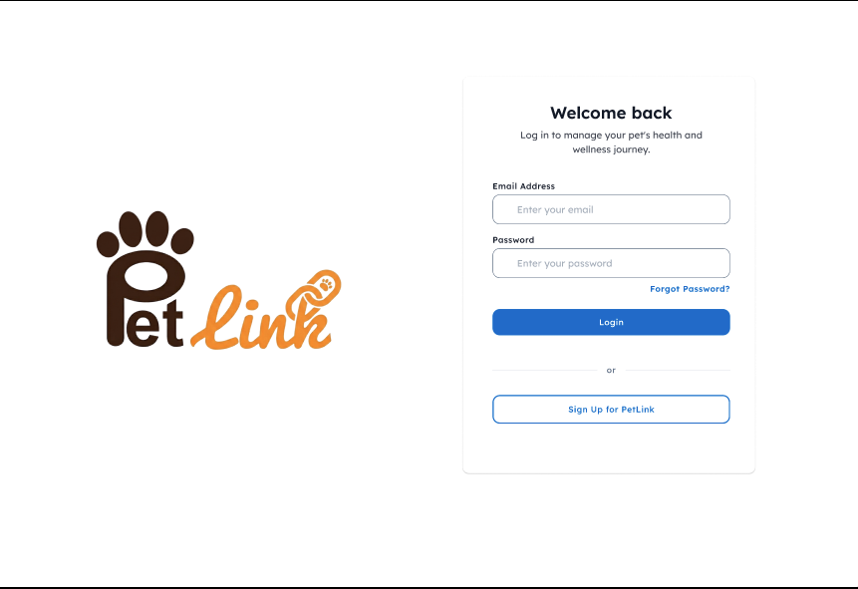
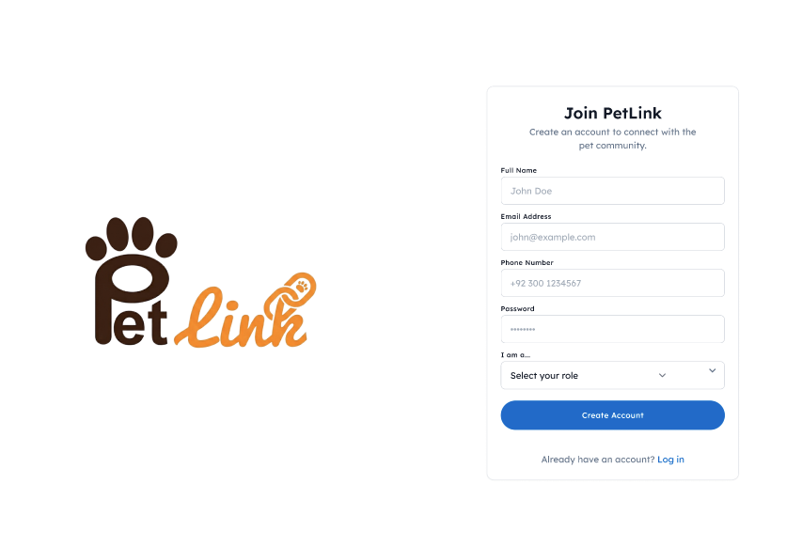
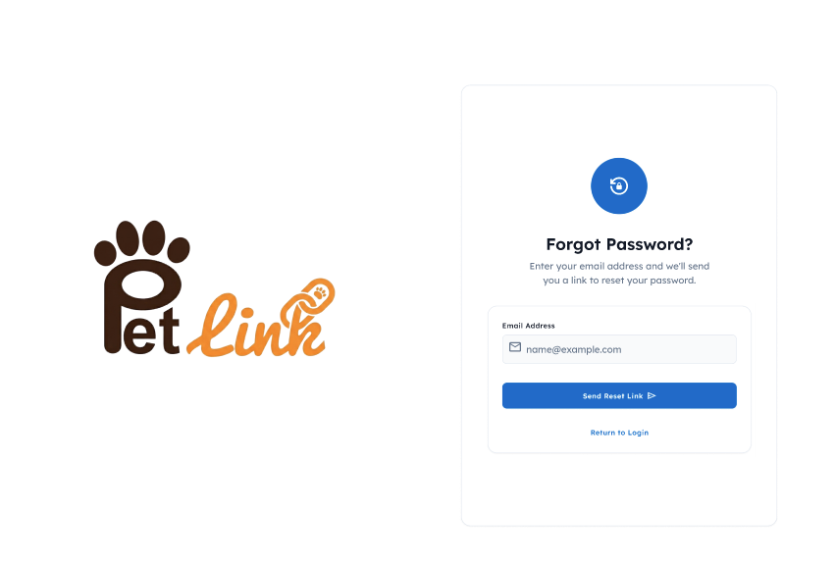

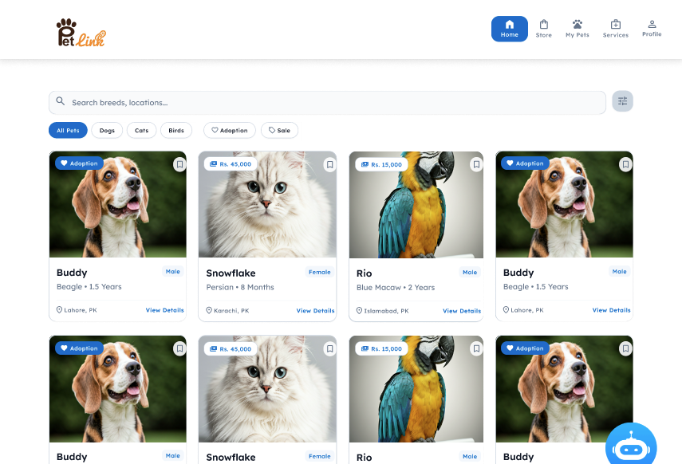

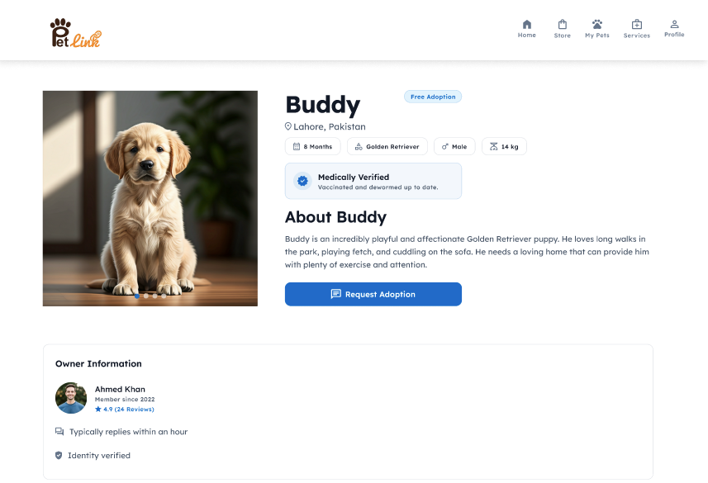

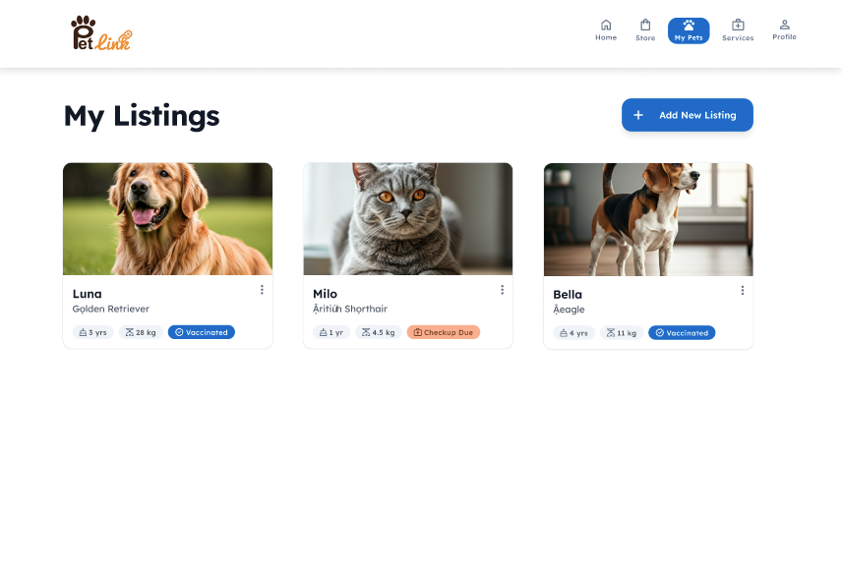
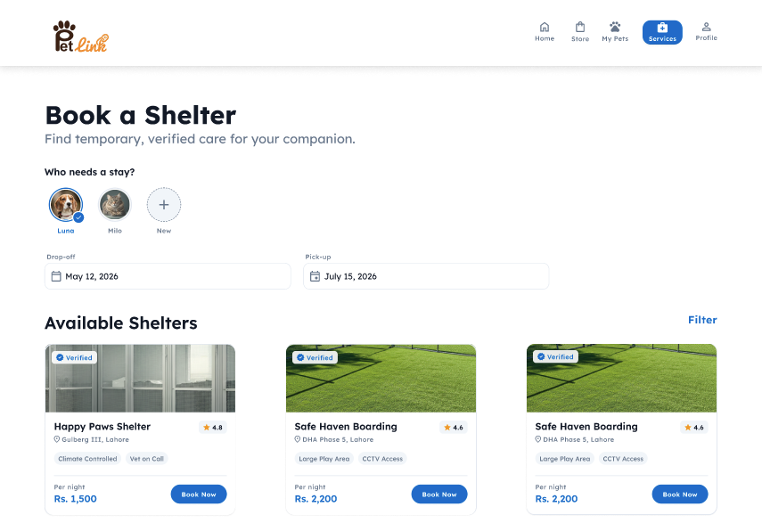

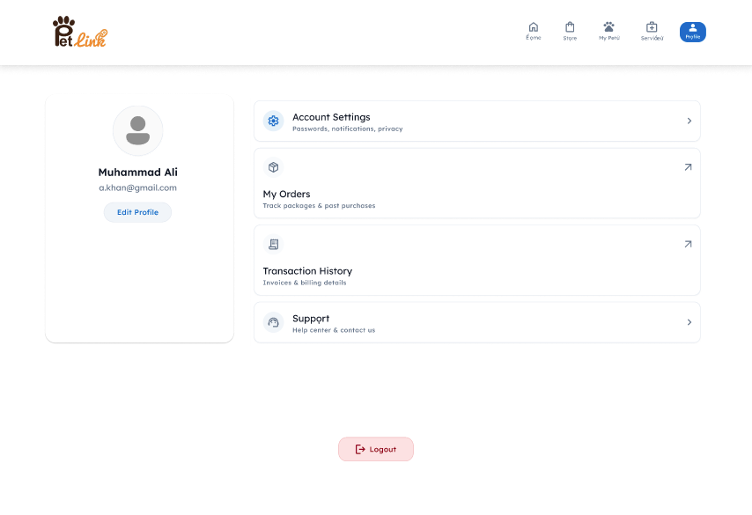
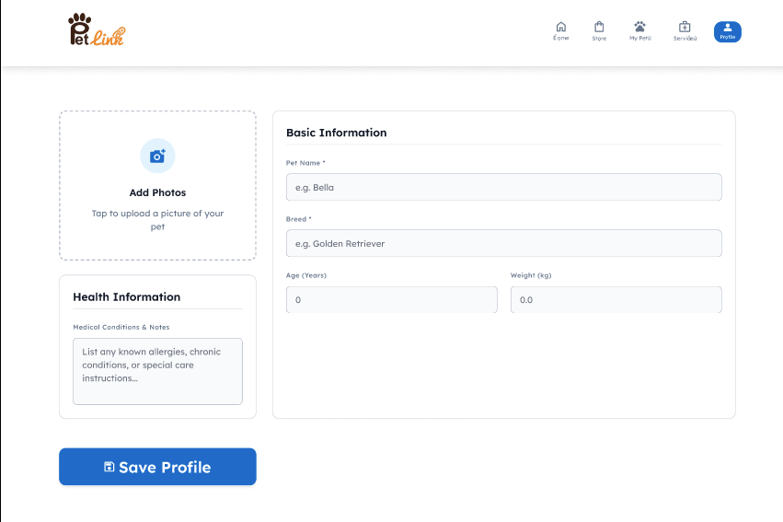

Sprint-wise Design Evolution

Sprint | Features Designed | Improvements
Sprint 1 | SRS alignment, authentication modules, user profile structure | Implemented JWT-based session architecture rather than simple cookies for cross-platform integration
Sprint 2 | Pet profile CRUD systems, marketplace listing pages, search feed | Added database indexing on search query keys to handle high concurrent search loads.
Sprint 3 | Boarding request flows, shelter dashboards, notification layers | Configured Socket.io real-time triggers to keep booking status states live.
Sprint 4 | E-commerce storefront backend, inventory manager | Isolated transaction logs from the core products table to prevent race conditions during checkout.
Sprint 5 | Stripe payment checkout integration, webhook monitors | Implemented automated payment webhooks to protect orders against client network drops.
Sprint 6 | ER Diagram, Class Diagram, detailed Schema Tables | Adjusted schemas to handle SQL-like relationships for clear structural reporting.
Sprint 7 | OpenAI Chatbot dialog systems, Google Maps locator | Proxying Maps API calls through the backend to keep api keys hidden from client source code.
Sprint 8 | Final design audit and documentation updates | Normalized schemas and completed UCP-spec sprint evolution logs.

Test Design

Test ID | Scenario | Expected Result
TC-01 | User enters valid login credentials | System logs in user and returns a signed JWT.
TC-02 | User enters incorrect password | System displays "Invalid Credentials" error.
TC-03 | User registers with an existing email | System displays "Email already in use" error.
TC-04 | User leaves required fields empty on signup | System displays validation error for required fields.
TC-05 | Pet owner creates a pet profile | Pet record is successfully created in the database.
TC-06 | Seller lists a pet for sale with a negative price | System blocks submission and displays a pricing error.
TC-07 | Seller lists a pet for adoption with a price > 0 | System blocks submission and enforces free adoption.
TC-08 | Buyer applies filters on marketplace feed | Feed displays listings matching only selected filters.
TC-09 | Pet owner requests boarding shelter | Shelter booking request status is saved as 'pending'.
TC-10 | Provider accepts a boarding request | Request status changes from 'pending' to 'accepted'.
TC-11 | Provider rejects a boarding request | Request status changes from 'pending' to 'rejected'.
TC-12 | Admin uploads a new storefront product | Product is stored and visible on the user storefront.
TC-13 | Admin attempts to set negative inventory levels | System rejects update and displays validation error.
TC-14 | User attempts to add out-of-stock item to cart | System blocks addition and displays "Out of Stock" banner.
TC-15 | User updates product quantity in cart | Cart total adjusts according to new quantity.
TC-16 | Buyer checks out with invalid card details | Stripe rejects payment and returns error code to client.
TC-17 | Stripe checkout transaction completes successfully | Order status changes to 'paid' and product stock decreases.
TC-18 | Daily cron task detects vaccine due in 2 days | Background task triggers email and push notifications.
TC-19 | User queries AI chatbot with pet medical questions | Chatbot returns basic guidance with emergency vet warning.
TC-20 | User searches for nearby veterinary clinics | Map displays markers for veterinary care facilities near GPS coordinates.
TC-21 | User disables location services on device | System displays location permission warning.
TC-22 | User logs out of their active session | Session is terminated and client-side token is cleared.
TC-23 | Multiple orders process for the last unit of stock | First transaction finishes, and subsequent checkouts fail.
TC-24 | Admin reviews monthly sales reports | Dashboard displays transaction history and revenue summaries.
TC-25 | Network connection is lost during Stripe checkout | Webhook updates order status once connection is restored.

Design Quality Attributes
Scalability:

PetLink is designed to support future growth and increasing numbers of users through a scalable cloud-based architecture. A Load Balancer distributes incoming requests across backend instances, preventing any single server from becoming overloaded. MongoDB Atlas provides horizontal scaling capabilities and supports large volumes of user, pet, marketplace, and transaction data. Frequently accessed information such as product listings, pet profiles, and marketplace searches can be cached using Redis to reduce database workload and improve response times.

Additionally, the system follows a modular service-based design, allowing new services and features to be added without affecting existing modules. This architecture enables the platform to efficiently support thousands of concurrent users while maintaining acceptable performance.

Security:

Security is a critical requirement of PetLink because the system manages user accounts, pet records, marketplace transactions, and payment processing.
The following security mechanisms are implemented:
- User passwords are hashed and salted using BCrypt before storage.
- JSON Web Tokens (JWT) are used for secure user authentication and session management.
- Role-Based Access Control (RBAC) restricts access to administrative and provider-specific functionalities.
- HTTPS encryption protects data transmitted between clients and servers.
- Stripe handles payment processing, ensuring sensitive payment information is never stored within the PetLink database.
- API keys for third-party services are securely stored using environment variables and are never exposed to client applications.
These security measures ensure confidentiality, integrity, and protection of user data.

Maintainability:

PetLink follows a layered architecture that separates the presentation, business logic, and data access layers. This separation reduces code complexity and improves maintainability.
The system uses:
- Modular component-based frontend development using React.js and React Native.
- Service-oriented backend modules developed using Node.js and Express.js.
- Consistent RESTful API design standards.
- Centralized database schemas and validation mechanisms using Mongoose.
- GitHub version control with feature-branch development workflows.
- Comprehensive documentation including UML diagrams, ER diagrams, API documentation, and test cases.
These practices make the system easier to understand, modify, test, and extend by future developers.

Deployment Considerations
- Hosting:

The React.js admin portal is hosted on Vercel. The Express.js backend runs on Render containers. The React Native mobile apps are distributed via Google Play Store and Apple App Store.

- Database:

MongoDB Atlas manages database clusters, automates daily database backups, and handles replica scaling

- Version Control:

The project uses GitHub for version control and team collaboration. A branching strategy is followed where separate branches are created for frontend, backend, and feature development before merging into the main branch after testing and review.

Future Enhancements
Although PetLink provides a comprehensive platform for pet management, adoption, shelter booking, health record tracking, and e-commerce services, several advanced features can be incorporated in future versions to further improve user experience and platform capabilities.

Veterinary Appointment Booking System

The platform can be extended to allow users to directly book appointments with nearby veterinary clinics. Integration with clinic schedules would enable real-time appointment management and automated reminders.

Lost and Found Pet Tracking

A dedicated Lost & Found module can be introduced where users can report missing pets, upload images, and receive alerts when matching reports are found nearby. AI-powered image matching can further improve recovery rates.

Pet Community and Social Features

A social networking section can be introduced where pet owners can share experiences, create posts, upload photos, join communities, and interact with other pet enthusiasts.

Microservices Migration
As the platform grows, the current layered architecture can gradually evolve into a microservices-based architecture where services such as authentication, marketplace management, payments, notifications, and AI assistance operate independently for improved scalability and maintainability.

Revised Project Plan
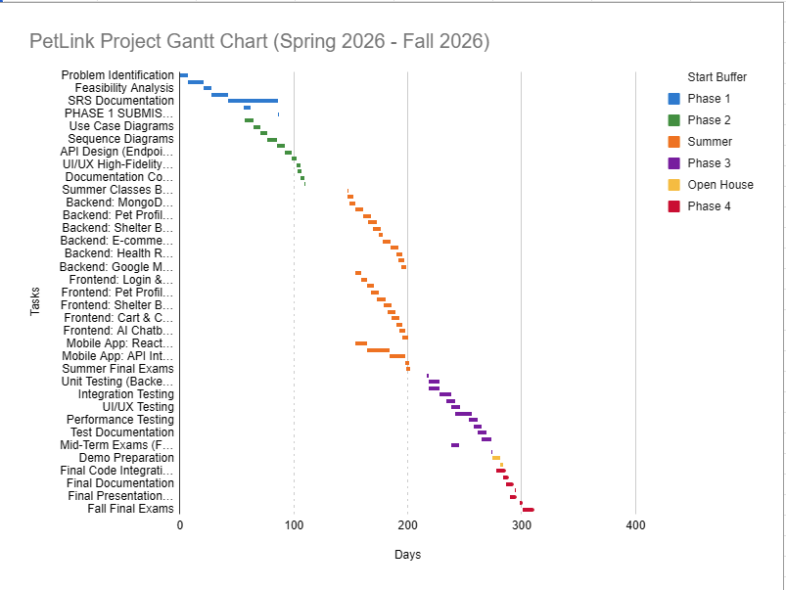


References
Ian Sommerville, Software Engineering, 10th Edition, Pearson, 2016.

Roger S. Pressman & Bruce Maxim, Software Engineering: A Practitioner's Approach, 9th Edition, McGraw-Hill, 2019.

Martin Fowler, Patterns of Enterprise Application Architecture, Addison-Wesley, 2002.

MongoDB Documentation.
https://www.mongodb.com/docs

React Documentation.
https://react.dev

React Native Documentation.
https://reactnative.dev

Express.js Documentation.
https://expressjs.com

Stripe API Documentation.
https://stripe.com/docs

Google Maps Platform Documentation.
https://developers.google.com/maps

JWT Documentation.
https://jwt.io

BCrypt Documentation.
https://github.com/kelektiv/node.bcrypt.js

Firebase Cloud Messaging Documentation.
https://firebase.google.com/docs/cloud-messaging

Appendix A: Glossary
Term Meaning

API Application Programming Interface
JWT JSON Web Token
CRUD Create, Read, Update, Delete
ERD Entity Relationship Diagram
DFD Data Flow Diagram
UML Unified Modeling Language
FCM Firebase Cloud Messaging
GPS Global Positioning System
UI User Interface
UX User Experience
MongoDB NoSQL Document Database
React Frontend JavaScript Library
React Native Mobile App Framework
Node.js JavaScript Runtime Environment
Express.js Backend Web Framework
Stripe Online Payment Gateway
AI Artificial Intelligence
Chatbot Automated Conversational Agent
RAG Retrieval Augmented Generation
HTTPS Secure Hypertext Transfer Protocol
BCrypt Password Hashing Algorithm
Webhook Event-driven HTTP Callback
JSON JavaScript Object Notation
SMTP Simple Mail Transfer Protocol
REST API Representational State Transfer API
Appendix B: IV & V Report
(Independent verification & validation)
IV & V Resource

Name Signature
Nabeel Ijaz
Ehsan Shahid

S# | Defect Description | Origin Stage | Status | Fix Time
 |  |  |  | Hours | Minutes
1 | Initial use case model did not include AI Chatbot interaction functionality. | Requirements Analysis | Fixed | 1 | 20
2 | DFD Level-1 was missing data flow between Marketplace Module and Database. | System Design | Fixed | 1 | 00
3 | Class Diagram contained duplicate attributes across User and Provider entities. | UML Design | Fixed | 1 | 45
4 | Test case coverage was incomplete for location-based services and AI chatbot interactions. | Test Design | Fixed | 1 | 00
Table 1: List of non-trivial defects

